Poinar & Buckley
Predatory behaviour of the social orb-weaver spider,
Geratonephila burmanica n. gen., n. sp. (Araneae:
Nephilidae) with its wasp prey, Cascoscelio incassus
n. gen., n. sp. (Hymenoptera: Platygastridae) in Early
Cretaceous Burmese amber

Historical Biology
2012

ScienceShot: 100-Million-Year-Old Spider Attack Caught in Amber
by Gretchen Cuda Kroen on 12 October 2012, 11:45 AM
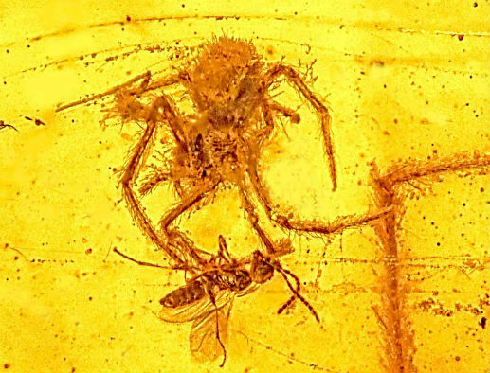
Credit: Photo by George Poinar Jr., Courtesy of Oregon State University
This one really was a fight for the ages. Researchers have discovered the only fossil known of a spider attack on prey caught in its web. The young male arachnid (top) was just about to pounce on a tiny parasitic wasp when the pair became smothered in tree resin in the Hukawng Valley of Myanmar 97 million to 110 million years ago. The result was a fossilized piece of amber that captured the event—complete with spider silk—in remarkable detail. The amber, described in the current issue of Historical Biology, also ensnared an adult male spider in the same web. Few arachnid species today are known to share a web, suggesting this is the oldest fossil evidence of social behavior in spiders.
Oregon State University headline: Fossil of ancient spider attack only one of its type ever discovered
Fox News headline: 100-million-year-old spider attack found in amber
Wired.com headline: 100-Million-Year-Old Spider Attack Recorded in Amber
Huffington Post headline: Ancient spider attack fossil found


Fossil of ancient spider attack only one of its type ever discovered
10-8-12
CORVALLIS, Ore. – Researchers have found what they say is the only fossil ever discovered of a spider attack on prey caught in its web – a 100 million-year-old snapshot of an engagement frozen in time.
The extraordinarily rare fossils are in a piece of amber that preserved this event in remarkable detail, an action that took place in the Hukawng Valley of Myanmar in the Early Cretaceous between 97-110 million years ago, almost certainly with dinosaurs wandering nearby.
Aside from showing the first and only fossil evidence of a spider attacking prey in its web, the piece of amber also contains the body of a male spider in the same web. This provides the oldest evidence of social behavior in spiders, which still exists in some species but is fairly rare. Most spiders have solitary, often cannibalistic lives, and males will not hesitate to attack immature species in the same web.
“This juvenile spider was going to make a meal out of a tiny parasitic wasp, but never quite got to it,” said George Poinar, Jr., a professor emeritus of zoology at Oregon State University and world expert on insects trapped in amber. He outlined the findings in a new publication in the journal Historical Biology.
“This was a male wasp that suddenly found itself trapped in a spider web,” Poinar said. “This was the wasp’s worst nightmare, and it never ended. The wasp was watching the spider just as it was about to be attacked, when tree resin flowed over and captured both of them.”
Spiders are ancient invertebrates that researchers believe date back some 200 million years, but the oldest fossil evidence ever found of a spider web is only about 130 million years old. An actual attack such as this between a spider and its prey caught in the web has never before been documented as a fossil, the researchers said.
The tree resin that forms amber is renowned for its ability to flow over insects, small plants and other life forms, preserving them in near perfection before it later turns into a semi-precious stone. It often gives scientists a look into the biology of the distant past. This spider, which may have been waiting patiently for hours to capture some prey, was smothered in resin just a split second before its attack.
This type of wasp, Poinar said, belongs to a group that is known today to parasitize spider and insect eggs. In that context, the attack by the spider, an orb-weaver, might be considered payback.
Both the spider and the wasp belong to extinct genera and are described in the paper. At least 15 unbroken strands of spider silk run through the amber piece, and on some of these the wasp was ensnared.
Its large and probably terrified eyes now stare for eternity at its attacker, moving in for the kill.


100-million-year-old spider attack found in amber
By Megan Gannon
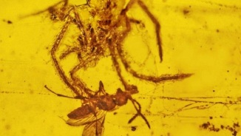
Published October 09, 2012

Photo: This is the only fossil ever discovered that shows a spider attacking prey in its web. Preserved in amber, it's about 100 million years old. (Oregon State University)
Researchers have found trapped in amber a rare dinosaur-age scene of a spider attacking a wasp caught in its web.
The piece of amber, which contains 15 intact strands of spider silk, provides the first fossil evidence of such an assault, the researchers said. It was excavated in a Burmese mine and dates back to the Early Cretaceous, between 97 million and 110 million years ago.
"This juvenile spider was going to make a meal out of a tiny parasitic wasp, but never quite got to it," George Poinar, Jr., a zoology professor at Oregon State University, said in a statement.
"This was a male wasp that suddenly found itself trapped in a spider web. This was the wasp's worst nightmare, and it never ended. The wasp was watching the spider just as it was about to be attacked, when tree resin flowed over and captured both of them."
Poinar and Ron Buckley, an amber collector from Kentucky, described the find in a paper published in the October issue of the journal Historical Biology. They wrote that while there are examples of amber-trapped insects caught in webs, "there is no previous fossil record of a spider attacking its ensnared prey."
The amber chunk also contains the body of another male spider in the same web, which might make the fossil the oldest known evidence of social behavior in spiders, according to the authors.
Both the spider and wasp species are today extinct. But the type of wasp (Cascoscelio incassus) belongs to a group that today is known to parasitize spider eggs, Poinor said. The attack on the wasp by the bristly orb-weaver spider, Geratonephila burmanica, might then be considered revenge.



100-Million-Year-Old Spider Attack Recorded in Amber
By Adam Mann | October 8, 2012 |
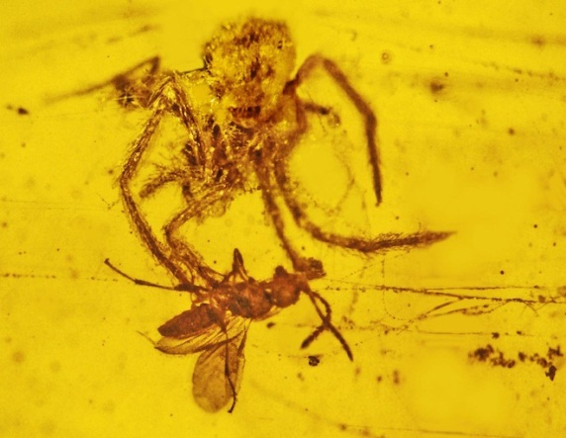
Looks like this 100-million-year old spider didn’t get to enjoy its final meal.
Trapped in a piece of amber, the juvenile spider appears to be on the cusp of devouring a male wasp that was caught in its web. Such a grisly scene between spider and prey has never before been found in the fossil record.
The amazing snapshot shows an event that occurred in the Early Cretaceous period, about 97 to 110 million years ago, in the Hukawng Valley of Myanmar, “almost certainly with dinosaurs wandering nearby,” as the press release about this discovery reports. The spider is a social orb-weaver spider, formally known as Geratonephila burmanica, and its victim is a wasp of the species Cascoscelio incassus. Both species are extinct today but the fossil suggests that insect behavior from the past is not too different from the present.
Related wasp species are known to parasitize spider eggs, so there is some poetic justice in the spider’s attack. “This was the wasp’s worst nightmare, and it never ended. The wasp was watching the spider just as it was about to be attacked, when tree resin flowed over and captured both of them,” said entomologist George Poinar Jr. of Oregon State University in the release.
This latest fossil doesn’t just capture the dramatic spider attack but also evidence of spider social life in the Early Cretaceous. Another spider, an adult male, is captured some distance away in the amber, co-habiting on the same web as the juvenile. Males of modern-day social orb-weavers are typically found living on female-constructed webs, where they assist in capturing insects and maintaining the web.
Droplets on the fossil web also contain aerial plankton (pollen, spores and dust particles) from the time. A paper about the discovery appears Oct. 8 in the journal Historical Biology.



Ancient Spider Attack Fossil Found: 100-Million-Year-Old Amber Is First Of Its Kind
Posted: 10/09/2012 8:54 am EDT
If you've always wondered what a 100-million-year-old spider attack might look like, today is your lucky day.
According to a newly published paper, researchers at Oregon State University have found the "only fossil ever discovered of a spider attack on prey caught in its web." The amber-encased spider is poised to devour a tiny parasitic wasp.
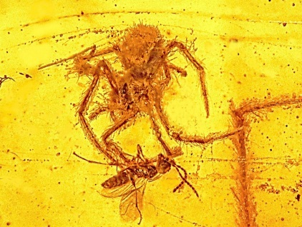
Photo Credit: Flickr/Oregon State University
“This was a male wasp that suddenly found itself trapped in a spider web,” George Poinar Jr., a professor emeritus of zoology at the university, said in a written statement. “This was the wasp’s worst nightmare, and it never ended. The wasp was watching the spider just as it was about to be attacked, when tree resin flowed over and captured both of them.”
Researchers say both the spider and the wasp belong to extinct genera. They added that the "extraordinarily rare" find may provide invaluable insight into the behavior of ancient spiders.
Oregon State University's website writes:
The...fossils are in a piece of amber that preserved this event in remarkable detail, an action that took place in the Hukawng Valley of Myanmar in the Early Cretaceous between 97-110 million years ago, almost certainly with dinosaurs wandering nearby.
Aside from showing the first and only fossil evidence of a spider attacking prey in its web, the piece of amber also contains the body of a male spider in the same web. This provides the oldest evidence of social behavior in spiders, which still exists in some species but is fairly rare. Most spiders have solitary, often cannibalistic lives, and males will not hesitate to attack immature species in the same web.
Poinar and Ron Buckley, an amber collector from Kentucky, have described the find in a paper published in the most recent issue of the journal Historical Biology. They wrote that while there are other examples of amber-trapped insects caught in spider webs, "this is the first fossil evidence of spider sociality and a fossil spider attacking prey trapped in its web."
This is not the first time in recent weeks that remarkable creepy crawlies have been found fossilized in amber.
In August, the Associated Press reported that scientists found three well-preserved, amber-encased ancient insects in Italy. The insects were said to be about 230 million years old -- about "100 million years older than what had been the previously known oldest critters trapped in fossilized tree resin."
The AP wrote:
While older insects have been found in rock fossils, these are different because they are not compressed and better preserved, said study lead author David Grimaldi, curator of the American Museum of Natural History in New York. And you can see more detail, he said.
"That's the great thing about amber. You can make this incredible detailed comparison with living species." Grimaldi said.

Garcia et al.
Extreme Reproduction and Survival of a True Cliffhanger:
The Endangered Plant Borderea chouardii
(Dioscoreaceae)

PLOS
2012

ScienceShot: Lonely Plant Enlists Ants
by Helen Fields on 12 September 2012, 5:01 PM |
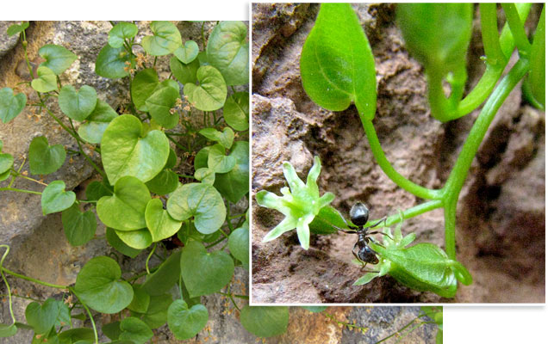
Credit: J. M. Olesen
On two vertical cliffs in the Pyrenees Mountains between France and Spain, 1000 or so puny, yamlike plants cling to life—and despite the plant's precarious cliffside existence, it somehow manages to reproduce. The plants, described by an alpine gardening Web site as "essentially modest foliage plants and mainly for the connoisseur," are all that's left of the species Borderea chouardii, a holdover from an otherwise vanished tropical ecosystem. Scientists suspected insect visitors carried pollen between the separate male and female plants, so with help from scaffolding and climbing gear, they spent 76 hours monitoring the plants in 2008 and 2009. Mostly, they saw ants. They ruled out wind pollination by setting out slides, then checking the pollen that collected on them. Then, through a series of experiments where they offered seeds to ants, they worked out that different species of ants were sharing the labor: Two species of ants pollinate the flowers and a third disperses the seeds, the team reports online today in PLoS ONE. However, the scientists note, relying on another species is risky, so how do the plants get away with putting all of their reproductive eggs in a few ant-carried baskets? One possibility is that the plants don't have to put out a lot of seed because they live so long—more than 300 years. And it probably helps that big herbivores can't reach them on their clifftop dwellings.
Scientific American headline: Sheer survival: Extreme strategy helps rare Pyrenees plant endure
Discover Magazine headline: Ancient flower lives only on two Spanish cliffs, and uses ants to survive



Sheer Survival: Extreme Strategy Helps Rare Pyrenees Plant Endure
September 19, 2012 |
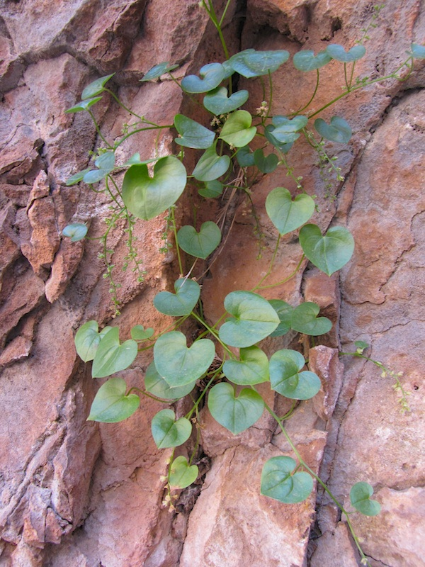
Amidst the jagged, vast Pyrenees, a little green herb with heart-shaped leaves clings to just two adjacent cliff sides. That's the worldwide geographic range of Borderea chouardii. The site is so inaccessible that the species was only discovered in the 1950s. For the past 18 years ecologist María Begoña García has clambered up scaffolds to check in on each specimen.
It turns out that the plant's reproductive strategy is just as eccentric as its location, making its survival even more perilous. Many of the seeds simply fall to the ground near the mother plant. But a substantial portion are dispersed by ants, which carry the seeds to new locations while bumbling along the cliffs.
The meandering ants also pollinate B. chouardii, making this an instance of "double mutualism," or a relationship in which one species relies on another to fulfill two roles. So what do the ants get out of this? They haul each seed back to their nest so larvae can dine on its elaiosome—a fatty, fleshy coating. After the feast the intact seed is dumped outside like garbage where it may eventually grow into a full plant. García, of the Spanish National Research Council, along with colleagues from the Autonomous University of Barcelona and Aarhus University in Denmark have identified three ant species that participate in this process: Lasius grandis, L. cinereus and Pheidole pallidula. The team's complete study of the plant was detailed in PLoS ONE on September 12.
Given this strange pollination and seed-dispersal strategy, it is especially impressive that B. chouardii and its ilk have inhabited the Pyrenees for roughly 10 million years, if not longer. The secret to the plant's perpetuity? Each one can live more than 300 years. —Daisy Yuhas



Ancient flower lives only on two Spanish cliffs, and uses ants to survive
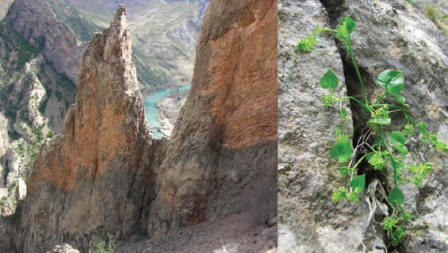
This story begins with a cliff-hanger. On the Spanish side of the Pyrenees mountains, around 850 metres above sea level, two adjacent cliff faces hold the entire population of Borderea chouardii – one of the world’s rarest plants. It’s a small herb that grows into crevices in the rock. Its leaves are heart-shaped and its flowers green and unassuming. There are around 10,000 individuals here, all growing on a square kilometre of vertical rock.
Now, Maria Garcia from the Spanish National Research Council has discovered the plant’s survival strategy, which involves three different species of ants. Through these multiple partnerships, B.chouardii quite literally clings to existence.
The plant is a relict, an ancient hanger-on from a time just after the death of the dinosaurs, when the Pyrenees enjoyed a tropical climate. It was discovered in 1952, and Garcia started studying it in 1993 by request of the Regional Government of Aragon, which is responsible for its management. Since then, she has regularly returned to the site by herself, and monitored all the accessible plants. “It’s not easy fieldwork, I can tell you, but exciting and fun,” she says.
Borderea plants are either male or female and not both. They need some way of carrying pollen from male flowers to females. They live high in the mountains, so wind seems like an obvious candidate. But when Garcia placed several sticky microscope slides next to a male flower, none of them picked up any pollen at all. So, not wind.
What about insects? Between 2008 and 2009, Garcia spent 76 hours just watching B.chouardii to see which insects visited its flowers. The majority were ants: Lasius grandis and Lasius cinereus in particular. That seems to fit, for B.chouardii has many of the traits you’d expect of an ant-pollinated flower. Low-growing, nectar-filled flowers that can be reached by a non-flying insect? Check. Small flowers that aren’t attractive to bigger insects? Check.
The ants are rare visitors but effective pollinators. Across 17 years of observations, Garcia has found that around 83 percent of the female flowers eventually bear fruit. But the plant then has another problem: How does it disperse its small, yellow seeds? It can sow itself: Borderea grows away from light, and some of the fruits end up headfirst in new crevices. Two-thirds of the seedlings germinate in this way. The two ants that pollinate B.chouardii might also contribute, since the plant has been found growing from their nests.
But the main seed disperser is another species of ant entirely – Pheidole pallidula. Garcia demonstrated this by setting up seed “cafes” – plastic seed-filled vials that were glued to the cliff. Only P.pallidula visited the vials, and dragged the seeds off to nearby crevices. It prefers the seeds of B.chouardii to those of related species, and it eats two thirds of the seeds it collects. The rest are left to germinate.
Garcia’s careful observations suggest that Borderea takes part in a “double mutualism” – partnering up with some ants to both pollinate its flowers and another to disperse its seeds. It’s a risky strategy. Even though three species of ants are involved, Garcia says that the plant is “putting all its stakes on just one kind of mutualist.” If ants disappear, perhaps if the surrounding cliff-sides become unsuitable for them, then B.chouardii would go extinct. “It is difficult to imagine other animals playing the ants’ role,” says Garcia.
But Borderea has another trick to mitigate its risk of extinction: an extraordinary lifespan of up to 300 years! In 17 years of monitoring, Garcia and other scientists have only counted 139 seedlings – just 8 per year. This is a plant that lives life in the slow lane. Its population is small and grows at an infinitesimal rate, but it’s in no rush.
The cliffs it hangs from are inaccessible to grazing animals, sheltered from the excesses of the elements, and constant in their climate. Few new individuals are born each year, but few survivors die. Several were lost to public works before Garcia came on the scene, but she soon set up a management plan that prevented further losses. One of her colleagues has also started a programme to grow them in 2 new sites. Will she succeed? We cannot say. This story ends with a cliff-hanger.
Reference: Garcia, Espadaler & Olesen. 2012. Extreme Reproduction and Survival of a True Cliffhanger: The Endangered Plant Borderea chouardii (Dioscoreaceae). PLOS ONE http://dx.doi.org/10.1371/journal.pone.0044657



Living fossil lives only on two rocks
September 27, 2012 - 06:39

A small herb from the past has miraculously survived on two adjacent vertical cliffs with the help of ants.
By: Rasmus Kragh Jakobsen
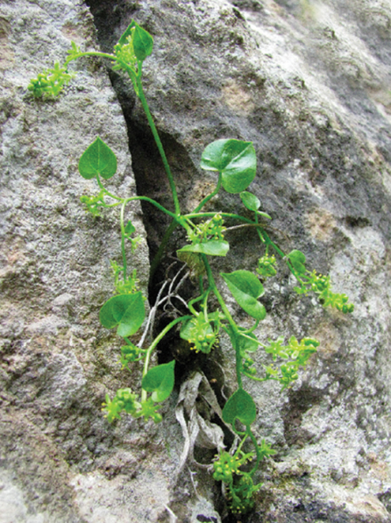
[[This herb has been growing into crevices of the rocks some 850 metres above the sea for millions of years. It’s a relic of a time when Spain was tropical and covered in rainforest. (Photo: García et al.)]]

One of the world’s rarest plants is literally clinging to life on two adjacent cliff sides on the Spanish side of the Pyrenees.
All the world’s 4-5,000 individuals of the small herb Borderea chouardii can be found within an area the size of a football field.
This yam-like herb, with its heart-shaped leaves and unassuming green flower, has been growing into crevices in the rock some 850 metres above the sea for millions of years.
Now Jens Mogens Olesen, a professor in ecology at Aarhus University, and two Spanish scientists reveal that the herb has a unique survival strategy in which it allies itself with three ant species. Only through these partnerships can the herb survive.

Herb discovered in 1952
The herb is a relic of a time when Spain was tropical and covered in rainforest.
As the planet subsequently cooled down and the tropical zone was pulled towards the equator, the little tropical herb remained perched on its Spanish rock.
Its closest relatives are extinct, but the Borderea chouardii strangely managed to pull through. And from their high-rise home they have lived to see Ice Ages and civilisations come and go.
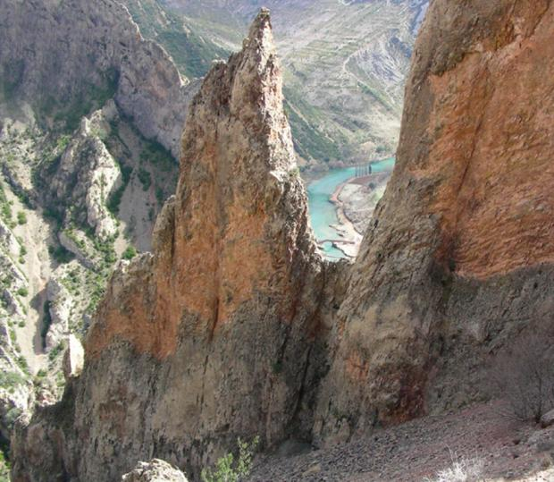
[[The tiny herb can only be found on these two cliff faces on the Spanish side of the Pyrenees. (Photo: García et al.)]]
This living fossil resides in an area so inaccessible that it wasn’t discovered until in 1952.
Olesen’s Spanish colleague, Maria B. García of the Instituto de Ecologia Pirenaico in Zaragoza, began studying the herb 17 years ago and has returned to the area every year since then to count and monitor the herbs, which have now been protected.
Olesen, who became involved in the project three years ago, says it has not been easy to study the herb:
“We used ropes to lower us down, and we spent many, many hours crawling around while hanging on the rope,” he says about the study, which has just been published in the scientific journal PLoS ONE.

Herb’s sex life revealed
The scientists have solved two riddles:
- How the herb manages to reproduce, despite the individuals being separated on a vertical rock surface.
- How it defies gravity and avoids plunging down to the foot of the cliff.
Let’s start with the one about sex: the individuals are either male or female. In order for reproduction to take place, pollen needs to be transported from the male to the female flower.
This is usually taken care of by the wind, but none of the sticky microscope slides that the researchers set up beside the male herbs picked up any pollen. So in this case, it couldn’t have been the wind.
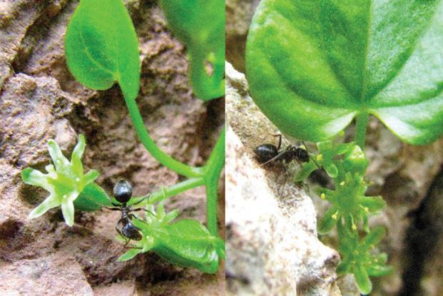
[[Ants ensure that the female plant (pictured left) receives pollen from the male plant (pictured right). (Photo: García et al.)]]
Another explanation could be flying insects. To test this hypothesis, the scientists decided to scrutinise the herbs with their own eyes. For a total of 76 hours they hung in ropes trying to spot something. They noted that bumblebees and butterflies visited other plants on the cliff, but they steered clear of the little herb.
In fact, very little happened at all.

Ants sort out the pollination
But occasionally a few ants – of the Lasius grandis and Lasius cinereus species – passed by, and it soon became clear that it’s these ants that pollinate the flowers.
The herb has arranged its flowers so that they point toward the rock and this enables the ants to reach the nectar.
As the ants slurp the nectar, they’re lubricated in pollen which, with a little luck, ends up on the female part of a flower further up the cliff.

The ants ‘carry’ the plant
So that’s the sex mystery solved then. But how about gravity? How did the herb make its way hundreds of metres up a cliff in the first place?

The answer, again, is ants. But this time we’re talking about a third species – Pheidole pallidula – which pays regular visits to the herb when it seeds.
The herb has another clever trick up its sleeve: it equips each seed with a small fatty compound which the ants find highly palatable. The ants then drag the seed off to their nest in the rock’s crevices, where the seeds that are not eaten are left to germinate.
The three scientists revealed this intimate partnership by gluing small plastic containers with herb seeds on the cliff.
Only the P. pallidula ants showed any interest in these containers – and they even preferred the herb’s seeds to other related foods.

A risky reproductive strategy
”It’s very rare to see plants using the same animal for pollination and for dispersion,” says Olesen.
Leaving the entire reproduction to one single type of animal is a rather risky strategy.
But as a buffer against extinction – for instance if the ants decide to find themselves a more suitable place to live – the herb has yet another trick up its sleeve:
It can live for up to 300 years. Maria García has demonstrated this by counting leaf scars on the tuber, which produces a new leaf every year.
“This is probably a world record for herbs,” says Olesen.

The herb-ant relationship is only just effective enough
In the 17 years that Maria García has been counting, only eight new plants have sprouted per year, on average. And since some individuals also die, the population only just grows enough to survive.

”It constantly lives on a razor’s edge. It has a really bad propagation, which is entirely dependent on ants,” he says.
On the other hand, it lives a tranquil and stable life up there on the cliff, free from the dangers of grazing animals such as sheep and goats.
It only grows on the north side, where the sun doesn’t shine. Here conditions are always slightly humid and the temperatures are fairly constant. In winter, the rock keeps warm, and in summer it maintains a nice and cool temperature.
“It’s well protected,” says Olesen. “However, a few years ago, some rocks fell down due to natural causes, and this had a negative effect on the Borderea chouardii population.”
Ultimately, the survival of this strange herb could depend on the strength of the rocks it's clinging to. There have also been attempts at ensuring the herb’s survival by trying to grow it elsewhere. Only time will tell if that will work.
Read the Danish version of this article at videnskab.dk
Country Denmark
From: http://sciencenordic.com/living-fossil-lives-only-two-rocks



It’s a Cliff-Hanger!
Posted by Sherry Ritter on September 26, 2012
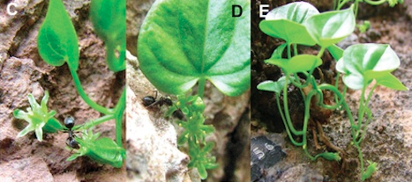
Borderea chouardii and some of its ants. Photo from PLoS ONE

On two vertical cliff faces in the Pyrenees of Spain, tucked into narrow rock crevices, grows a tiny plant, Borderea chouardii. The entire population of approximately 10,000 plants lives in an area of only 1 sq km (approximately 250 acres). Its restricted habitat and precarious setting has earned it a rating of Critically Endangered by the International Union for the Conservation of Nature (IUCN).
How does this plant get pollinated? As you can see from the photo, the flowers are green and grow close to the ground, so are unlikely to attract moths, butterflies, hummingbirds, or bees. A scientist studying these flowers, Maria Garcia from the Spanish National Research Council, determined that the pollen doesn’t travel in the winds. After many hours of observation – while hanging from a rope, we assume – Ms. Garcia concluded that the flower depends on two species of ants to carry the pollen from the male flowers to the female ones.
How does this plant get its seeds to grow in the appropriate habitat, those narrow crevices? The seeds get planted in two ways. About a third of the seeds are sown by another species of ant, which carries seeds into crevices to eat. Many of those seeds are left uneaten and then germinate. The plant sows about two-thirds of its seeds itself; Borderea grows away from light, and some of the fruits end up headfirst in new crevices.
This plant’s life is a cliff-hanger, and we mean in more ways than just its physical environment. Garcia and other researchers have only counted 139 seedlings in 17 years of monitoring. That, and being dependent on just two species of ants for pollination, makes this species vulnerable to changes in its environment. Fortunately, this is offset by its lifespan of up to 300 years.
From: http://ben.biomimicry.net/coolbio/2012/its-a-cliff-hanger/



These tiny plants can live for 300 years with the help of their friends the ants
By Sarah Laskow
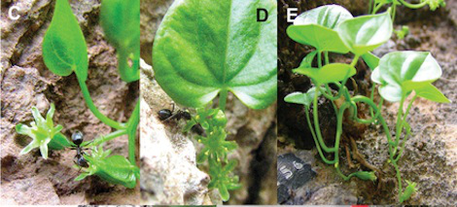Photo courtesy of PLoS ONE.
The herb Borderea chouardii is like the Disney heroine of plants. It’s pretty and delicate, it has magic powers, and it lives by itself with only its friendly animal helpers for company. In this case, the magic power is a super-long lifespan, and the animal helpers are three different species of ants.
There are only about 10,000 of these little plants, Ed Yong writes at Discover. They grow in the Pyrenees and have been around since the dinosaurs. And it’s not just the species that’s old — each individual plant lives for about 300 years! So they clearly have learned a thing or two about survival.
Living so isolated in the mountains, though, any species needs a little bit of help. These guys have chosen ants. There are two species of ants that visit them and carry their pollen from plant to plant. And there is an entirely different species of ant that comes by and carries away their seeds, about two-thirds of which get eaten. The plants do have other ways of spreading their seed (basically, growing towards crevices and hoping their fruit drops in). But without the ants, they would be screwed.
So, fingers crossed that the ants make it through climate change and all. Perhaps a plant that lives 300 years can afford to wait a little bit for some other insect to discover the deliciousness of its seeds. But we’d rather not have to find out.
From: http://grist.org/list/these-tiny-plants-can-live-for-300-years-with-the-help-of-their-friends-the-ants/

Marzluff et al.
Brain imaging reveals neuronal circuitry underlying the
crow’s perception of human faces

PNAS
2012

ScienceShot: Bird Brains Show Their Fear of Faces
by Moheb Costandi on 10 September 2012, 3:10 PM |
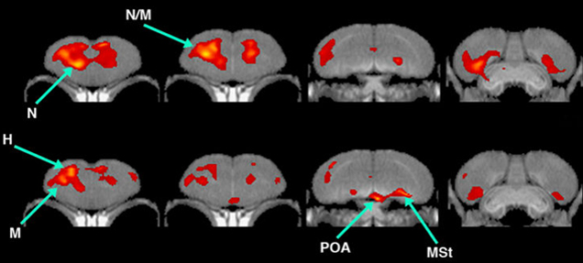
Credit: J. Marzluff et al., PNAS Early Online Edition (2012)

Crows don't forget a face—especially one they're afraid of. Now, images of the birds' brain activity reveal what happens neurologically when they see a familiar face. Researchers from the University of Washington donned identical masks and captured 12 wild American crows. The scientists kept the birds in captivity for a month and fed them while wearing a different, "caretaker" mask. Afterward, the team showed the birds humans wearing the two different masks and monitored the crows' brain activity using positron emission tomography. The "threatening" mask the researchers wore to capture the birds activated brain regions associated with fear, the team reports today in the Proceedings of the National Academy of Sciences. The caretaker mask worn to feed the birds, on the other hand, activated another set of regions associated with reward and motivation. These results suggest that American crows, like humans, distinguish faces by combining visual information with preexisting memories.
U. of Washington headline: Crows react to threats in human-like way
New Scientist headline: Bran scans show how crows distinguish friend from foe
RedOrbit headline: Crows associate faces with feelings

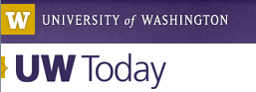

Crows react to threats in human-like way
By Sandra Hines

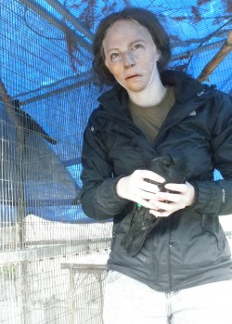
Marzluff Lab/U of Washington
Ila Palmquist, a member of John Marzluff’s laboratory group, wears a threatening mask while catching and handling crows. The mask carries a neutral expression so the associations made by the crows was based on their treatment.
Cross a crow and it’ll remember you for years.
Crows and humans share the ability to recognize faces and associate them with negative, as well as positive, feelings. The way the brain activates during that process is something the two species also appear to share, according to new research being published this week.
“The regions of the crow brain that work together are not unlike those that work together in mammals, including humans,” said John Marzluff, University of Washington professor of environmental and forest sciences. “These regions were suspected to work in birds but not documented until now.
“For example it appears that birds have a region of their brain that is analogous to the amygdala of mammals,” he said. “The amygdala is the region of the vertebrate brain where negative associations are stored as memories. Previous work primarily concerned its function in mammals while our work shows that a similar system is at work in birds. Our approach could be used in other animals – such as lizards and frogs – to see if the process is similar in those vertebrates as well.”
Marzluff is the lead author of a paper being published the week of Sept. 10 in the online edition of the Proceedings of the National Academy of Sciences.
Previous research on the neural circuitry of animal behavior has been conducted using well-studied, often domesticated, species like rats, chickens, zebra finches, pigeons and rhesus macaques – and not wild animals like the 12 adult male crows in this study.
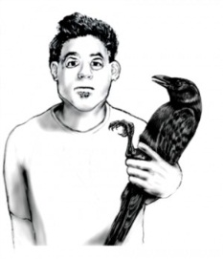
Jack DeLap/U of Washington
Crows were captured by investigators wearing threatening masks. Although never treated in a threatening way, the crows associated negative feelings with the mask
The crows were captured by investigators all wearing masks that the researchers referred to as the threatening face. The crows were never treated in a threatening way, but the fact they’d been captured created a negative association with the mask they saw. Then for the four weeks they were in captivity, they were fed by people wearing a mask different from the first, this one called the caring face. The masks were based on actual people’s faces and both bore neutral expressions so the associations made by the crows was based on their treatment.
In most previous neurological studies of animals, the work usually starts by sedating the animals, Marzluff said. Instead the approach developed by the UW involved injecting a glucose fluid commonly used in brain imaging into the bodies of fully alert crows that then went back to moving freely about their cages. The fluid flooded to the parts of the crow brains that were most active as they were exposed for about 15 minutes to someone wearing either the threatening or caring mask.
Then the birds were sedated and scans made of their brains. All the birds were returned to the wild once all the work was completed.
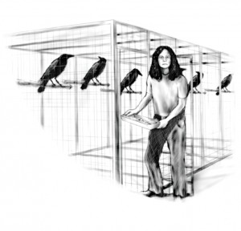
Jack DeLap/U of Washington
Investigators wearing caring masks fed the crows for four weeks.
“Our approach has wide applicability and potential to improve our understanding of the neural basis for animal behavior,” wrote Marzluff and co-authors Donna Cross, Robert Miyaoka and Satoshi Minoshima, all faculty members with the UW’s radiology department. The department funded the preliminary work while the main project was conducted using money from theUW’s Royalty Research Fund.
Most neurological studies to date in birds have concerned their songs – how their brain registers what they hear, how they learn and come up with songs of their own. This new approach enables researchers to study the visual system of birds and how the brain integrates visual sensation into behavioral action, Marzluff said.
Among other things the findings have implications for lowering the stress of captive animals, he said.
“By feeding and caring for birds in captivity their brain activity suggests that the birds view their keepers as valued social partners, rather than animals that must be feared. So, to keep captive animals happy we need to treat them well and do so consistently,” he said.
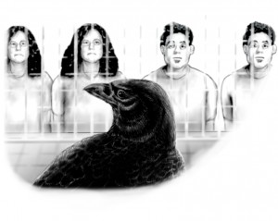
Jack DeLap/U of Washington
Before brain scanning, a crow was exposed on and off for about 15 minutes to a person wearing either a caring mask or a threatening mask, but not both.
Intriguingly, Marzluff said the findings might also offer a way to reduce conflict between birds and endangered species on which they might be feeding. In the Mojave Desert, for instance, ravens prey on endangered desert tortoises. And on the West and East coasts, crows and ravens prey on threatened snowy plovers.
“Our studies suggest that we can train these birds to do the right thing,” Marzluff said. “By paring a negative experience with eating a tortoise or a plover, the brain of the birds quickly learns the association. To reduce predation in a specific area we could train birds to avoid that area or that particular prey by catching them as they attempt to prey on the rare species.”
The partnering of neuroscientists with ecologists could be used to better understand the neural basis of cognition in widely diverse animals, said co-author Cross. For example, her suggestion to use the glucose technique prior to brain scans, so the crows could be fully awake, could be used for other animals.
“This was a true collaboration that would never be possible without the people that were involved with very different areas of expertise,” she said.



Brain scans show how crows distinguish friend from foe
10 September 2012 by Sara Reardon
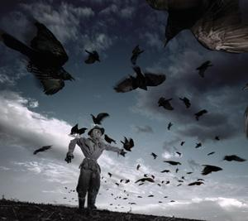
A case of mistaken identity? (Image: James Nelson/Stone/Getty)
You can run from a crow that you've wronged, but you can't hide. Wild crows remember human faces in the same way that mammals do.
Crows can distinguish human faces and remember how different people treated them, says John Marzluff of the University of Washington in Seattle.
To work out how the crows process this information, Marzluff had members of his team wear a latex mask as they captured 12 wild American crows (Corvus brachyrhynchos). The crows learned to associate the captor's mask with this traumatic experience. While in captivity, the crows were fed and looked after by people wearing a different mask.
After four weeks, the researchers imaged the birds' brains while they were looking at either the captor or feeder mask. The brain patterns looked similar to those seen in mammals: the feeder sparked activity in areas involved in motivation and reward, whereas the captor stimulated regions associated with fear.
The result makes sense, says Kevin McGowan of Cornell Lab of Ornithology in Ithaca, New York. Crows don't mind if humans are in their habitat – but they need to keep a close eye on what we do.
Journal reference: Proceedings of the National Academy of Sciences, DOI: 10.1073/pnas.1206109109


Crows Associate Faces With Feelings
September 11, 2012

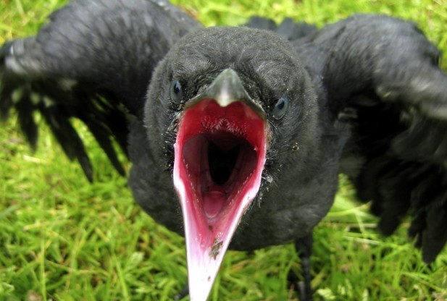
Image Credit: Photos.com
Lee Rannals for redOrbit.com – Your Universe Online
If crows ever freaked you out before, then you’re in for a whole new set of chill bumps. New research indicates that crows are able to recognize faces and associate them with feelings.
Scientists writing in the Proceedings of the National Academy of Sciences said that crows have human-like ways of attaching negative and positive emotions to particular faces.
“The regions of the crow brain that work together are not unlike those that work together in mammals, including humans,” John Marzluff, University of Washington professor of environmental and forest sciences, said in a recent statement. “These regions were suspected to work in birds but not documented until now.
He said it appears the birds have a region of their brain that is similar to the amygdala of mammals, which is the region of the vertebrate brain where negative associations are stored as memories.
“Previous work primarily concerned its function in mammals while our work shows that a similar system is at work in birds,” he said. “Our approach could be used in other animals – such as lizards and frogs – to see if the process is similar in those vertebrates as well.”
During the study, crows were captured by investigators while they were wearing masks that were considered to be threatening.
The crows were not mistreated, but the fact that they were captured was enough to set off an alarm inside their head of a threatening association.
For four weeks they were placed in captivity, and fed by people wearing a mask different than the first, which they called “the caring face.”
The masks were based on actual people’s faces and both had neutral expressions so the associations made by the crows was based on their treatment.
During most previous neurological studies of animals, the work starts by sedating the animals, according to Marzluff. However, during the recent study, they injected a glucose fluid commonly used in brain imaging into the bodies of fully alert crows that went back to moving freely about their cages.
The fluid flooded the parts of the crow brains that were most active as they were exposed for about 15 minutes to someone wearing either the threatening or caring mask.
The birds were then sedated, and the team made scans of their brains. Afterwards, all the birds were returned to the wild.
“Our approach has wide applicability and potential to improve our understanding of the neural basis for animal behavior,” the researchers wrote in the journal.
Marzluff said that this new approach enables the team to study the visual system of birds and how the brain integrates the visual sensation to behavior action.
He said among other things, the findings have implications for lowering the stress of captive animals.
“By feeding and caring for birds in captivity their brain activity suggests that the birds view their keepers as valued social partners, rather than animals that must be feared,” he said. “So, to keep captive animals happy we need to treat them well and do so consistently.”
Marzluff said the findings might offer a way to reduce conflict between birds and endangered species on which they might be feeding.
“Our studies suggest that we can train these birds to do the right thing,” Marzluff said. “By paring a negative experience with eating a tortoise or a plover, the brain of the birds quickly learns the association. To reduce predation in a specific area we could train birds to avoid that area or that particular prey by catching them as they attempt to prey on the rare species.”


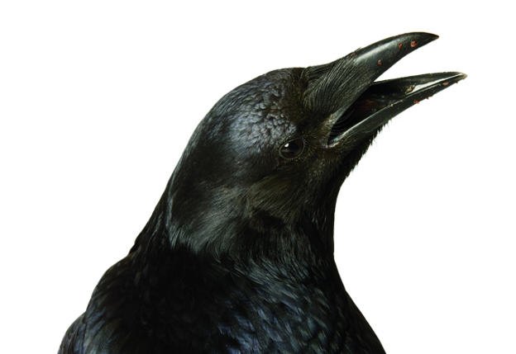
Photograph by Joel Sartore

A Crow Never Forgets
The remarkable birds, like us, can remember people's faces.
By Jhaneel Lockhart | Published: January-February 2013
Scientists know that crows, like people, can recognize specific human faces—even years after a single encounter—and that they can associate them with negative or positive feelings. Wildlife scientist John Marzluff and colleagues at the University of Washington wondered if birds therefore process faces similarly to humans.
To find out, they wore masks and captured crows, creating a negative association in the birds. Then they switched to different masks while feeding and caring for their short-term captives. PET scans of the birds’ brains showed that the threatening masks activated regions that regulate responses like attention and memory of fear. Caring masks, in contrast, activated memory and motivation, hunger, and reward regions.
“Their brains are small in comparison to ours, but they’re using them in pretty much the same way to make all these complex decisions,” says Marzluff, “and they’re apparently doing it in ways that are as complicated as our own.” The findings have several possible applications, he adds. Bird owners, for instance, might consider wearing a mask when administering a shot or other traumatic care. And where wild crow populations feed on threatened species, like snowy plovers, biologists might reduce predation by catching the predators as they swoop in, making it a negative experience that the birds quickly learn to avoid.
From: http://www.audubonmagazine.org/articles/birds/crow-never-forgets
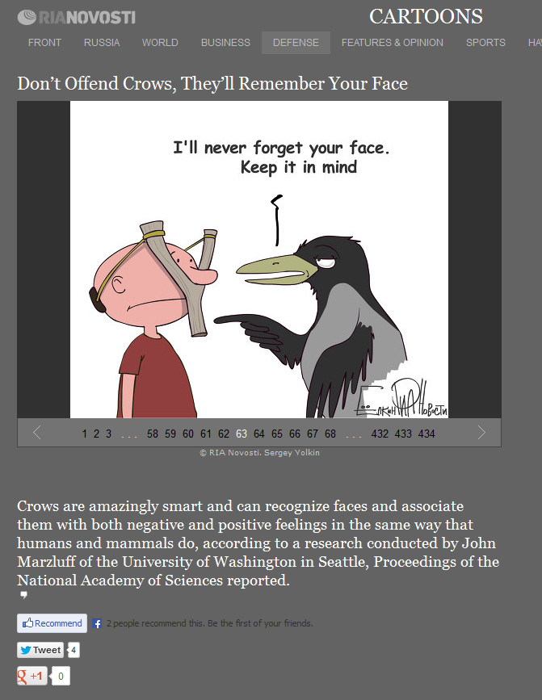
From: http://en.beta.rian.ru/cartoons/20120912/175913150.html

Melody and Schmidt
Northward range extension of an endemic soil decomposer with a distinct trophic position

Biology Letters
2012

ScienceShot: Can of Worms
by Sid Perkins on 24 July 2012, 7:01 PM |
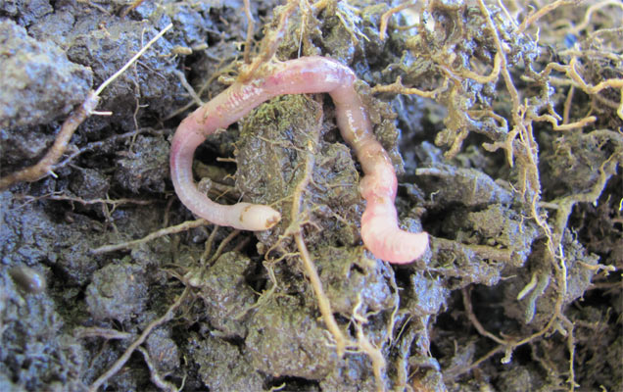
Credit: Carol Melody and Olaf Schmidt
A survey on a farm near Dublin has turned up large numbers of a species of earthworm typically found in only southern France, more than 1000 kilometers farther south. Researchers found Prosellodrilus amplisetosus, the southern European earthworm (above), in soils at six of the 11 different habitats they surveyed, including large concentrations of the worms in a meadow and along the edge of a pasture that had been reseeded. Ratios of the carbon and nitrogen isotopes in the invasive worms' tissues indicate that the creatures—which consume soil to extract some of its organic material—are tapping into resources unused by native worms, possibly explaining their success, the researchers report today in Biology Letters. It isn't clear how these worms reached the farm, but they were probably stowaways in soil surrounding the roots of hedges or other plants brought to the farm decades ago. But isolated reports of the species from other sites—including northeastern Spain, east-central France, and northeastern Ireland—suggest that P. amplisetosus can become established far afield of its normal range. Although the worms don't seem to be reducing populations of native worms, if they become widespread they could exacerbate climate change by releasing large amounts of carbon currently locked away in soils, the researchers speculate.
University College of Dublin headline: Mediterranean earthworm species found thriving in Ireland as global temperatures rise
Irish Examiner headline: Mediterranean worms thriving in Dublin



Mediterranean earthworm species found thriving in Ireland as global temperatures rise
Scientists have discovered a thriving population of Mediterranean earthworms in an urban farm in Dublin.
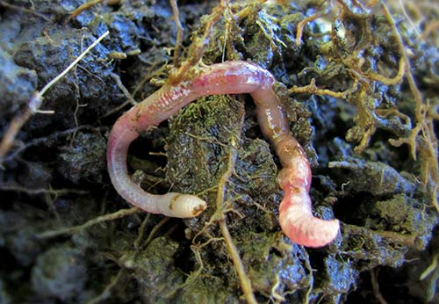
The findings by University College Dublin scientists published in the journal Biology Letters today (25 July 2012) suggest that rising soil temperatures due to climate change may be extending the geographical habitat range of the earthworm Prosellodrilus amplisetosus.
“Soil decomposer species including earthworms are frequently introduced into non-native soils by human activities like the transportation of nursery plants or live fish bait,” says Dr Olaf Schmidt from the School of Agriculture and Food Science, and the Earth Institute, University College Dublin, one of the authors of the report.
“There have been a few recordings of the earthworm P. amplisetosus outside of its native range in the Aquitaine region of south-western France, but now we have discovered a successfully thriving population in Ireland, about 1,000 km north of its native habitat.”
Urban farms have higher temperatures than rural farms so the scientists suggest that this may have helped P. amplisetosus to become established in this new location. The mean yearly air temperature in Aquitaine in south-western France is about 3 degrees higher than in Dublin, Ireland.
The finding brings to 27 the total number of known earthworm species living in Irish soils.
According to the scientists, the Mediterranean species of earthworm P. amplisetosus is not an invasive species in Ireland. It does not directly compete for resources with the other resident species.
“By comparing the chemical composition of the worms, we discovered that the newcomers feed on a portion of the soil that the other resident earthworms do not use,” says Carol Melody, a PhD student at the School of Agriculture and Food Science, University College Dublin, who co-authored the research paper.
“P. amplisetosus is a soil decomposer that eats organic carbon in portions of the soil to which the resident worm species don’t have access,” she says.
“If other soil decomposers like P. amplisetosus start to expand their habitat ranges we could see increasing amounts of CO₂ being released from the soil where previously this carbon had been locked up because it was inaccessible to native earthworm species,” says Dr Schmidt.
A sample of the P. amplisetosus found thriving in Dublin, Ireland, has been deposited in the Natural History Museum in London to archive the scientific discovery and to make scientists in Britain aware of the southern vagrants.

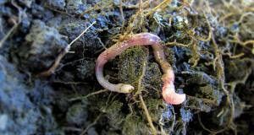
Mediterranean worms thriving in Dublin
Thursday, July 26, 2012 - 10:58 AM
A thriving colony of Mediterranean French earthworms has been found on a farm in Dublin.
Global warming could explain how the worms swapped their home in sunny south-west France for Ireland, scientists believe.
Rising soil temperatures may be extending the habitat range of the Gallic worm, Prosellodrilus amplisetosus.
"Soil decomposer species including earthworms are frequently introduced into non-native soils by human activities like the transportation of nursery plants or live fish bait," said Dr Olaf Schmidt, from University College Dublin.
"There have been a few recordings of the earthworm P. amplisetosus outside of its native range in the Aquitaine region of south-western France, but now we have discovered a successfully thriving population in Ireland, about 1,000 kilometres north of its native habitat."
A study of the worms led by Dr Schmidt appears in the Royal Society journal Biology Letters.
Urban farms have higher temperatures than rural farms, which may have helped the worms become established in their new home, say the researchers.
The average annual temperature in Aquitaine is about 3C higher than in Dublin.
The discovery brings the total number of known earthworms living in Irish soils to 27.
According to the scientists, the French worm should not be regarded as an "invasive species", since it does not directly compete for resources with other native worms.
"By comparing the chemical composition of the worms, we discovered that the newcomers feed on a portion of the soil that the other resident earthworms do not use," said co-author Carol Melody, a Phd student also from University College Dublin.
"P. amplisetosus is a soil decomposer that eats organic carbon in portions of the soil to which the resident worm species don't have access."
But Dr Schmidt warned that the worm's feeding habits could lead to higher greenhouse gas emissions.
"If other soil decomposers like P. amplisetosus start to expand their habitat ranges we could see increasing amounts of carbon dioxide being released from the soil where previously this carbon had been locked up because it was inaccessible to native earthworm species," he said.

Science

Earthworm From France Makes Its Way to Ireland

By SINDYA N. BHANOO

Published: July 30, 2012

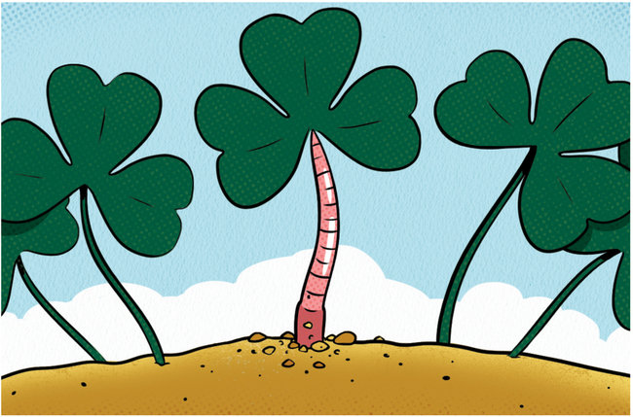 Chris Gash

An earthworm species rarely seen outside the Aquitaine region of southwestern France is thriving more than 600 miles to the north, across the sea in Ireland, a new study reports.
The earthworm’s new habitat, on an urban farm in Dublin, may have been made possible by rising soil temperatures caused by climate change, said Olaf Schmidt, a biologist at University College Dublin and an author of the study.
“What is really interesting about these worms is that there are about 25 species restricted to a small area in the southwest of France,” he said. “None have moved outside this area, and suddenly we found them in a routine survey of farms in Dublin.”
The worm’s introduction to Ireland was probably a result of human activity; it may have arrived with garden plants being imported to Ireland. Though a newcomer to the island, the worm species, Prosellodrilus amplisetosus, does not appear to be invasive, and is happily coexisting with the 30 other earthworm species already found in Ireland, Dr. Schmidt said.
“This new worm eats a different carbon and nitrogen fraction in the soil,” he said. “In fact, it could be that they will contribute to the maintenance of the soil structure and nutrients. We will have to see.”
The mean yearly temperature in Aquitaine is about five degrees higher than that in Dublin. But globally, temperatures are rising.
“It’s very tempting to speculate that they only survive here now because of an increase on average of temperatures,” Dr. Schmidt said.
He and his colleague Carol Melody, also of University College Dublin, report their findings in the journal Biology Letters.

A version of this article appeared in print on July 31, 2012, on page D3 of the New York edition with the headline: Earthworm From France Makes Its Way to Ireland.

From: http://www.nytimes.com/2012/07/31/science/earthworm-species-makes-its-way-to-ireland-from-france.html?_r=0



Mediterranean Earthworm Species Thriving in Ireland
Aug. 13, 2012
A Mediterranean earthworm species has been found 1000km from its native habitat; an urban farm in Dublin. Prosellodrilus amplisetosus is usually found in the Aquitaine region of South France but, according to UCD scientists, rising global temperatures have allowed the species to thrive in Ireland.
The findings which were published in Biology Letters brings to 27 the number of earthworm species living in Irish soil. Earthworms are essential to the farmer as they improve soils through drainage, aeration (through burrowing), soil structure and increase organic matter (from decomposition).
The Mediterranean species of earthworm P. amplisetosus should not have a negative impact on Irish species, as they don’t directly compete for the same resources. According to Carol Melody, a PhD student at the School of Agriculture and Food Science, University College Dublin, who co-authored the research paper,
“P. amplisetosus is a soil decomposer that eats organic carbon in portions of the soil to which the resident worm species don’t have access,”.
The importance of the earthworm to agriculture and ultimately our food source and has been known for centuries. A sample of the P. amplisetosus living in Ireland has been deposited in the Natural History Museum in London to archive the scientific discovery.

Hawlena et al.
Fear of predation slows plant-litter decomposition

Science
2012

ScienceShot: Go in Fear, Grasshopper
by Sid Perkins on 14 June 2012, 2:00 PM
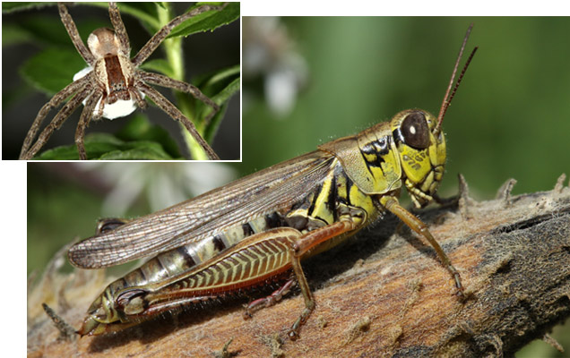
Credit: Dror Hawlena
Fear is a horrible thing, and new research suggests that its effects can extend even beyond death. In a field experiment, scientists raised red-legged grasshoppers (Melanoplus femurrubrum, image), a North American species, in the presence of predatory spiders (Pisaurina mira, the nursery web spider, inset). Analyses revealed that the fear-addled grasshoppers ended up with a higher carbon-to-nitrogen ratio in their bodies than the presumably stress-free insects raised without spiders -- largely because their constantly amped-up metabolism obliged them to burn nitrogen-bearing protein to generate energy-providing glucose. The lower amounts of nitrogen in the carcasses of fearful grasshoppers didn't affect how quickly they decomposed in soil after death, but it did substantially slow down the decay of leaf material later added to the soil, the researchers report online today in Science. That slowdown, in turn, likely stems from the decreased efficiency of soil microbes and fungi, which need nitrogen to perform their decomposition duties. Because the metabolic changes triggered by fear are likely common to all prey species, the new findings reveal a new way that animals—both predators and prey—influence the cycling of nutrients through ecosystems.
Hebrew University of Jerusalem headline: Hebrew University, Yale researchers show how grasshoppers ‘stressed’ by spiders affect the productivity of our soil
Los Angeles Times headline: Fear factor seems relevant in decomposing bug’s effect on soil
ABC Science (Australia) headline: Scared grasshoppers change soil chemistry
Discover Magazine headline: Fear of spiders changes bodies of grasshoppers and makes plants decay more slowly
Pacific Standard headline: Fear powers zombie bugs


17 June, 2012
Hebrew University, Yale researchers show how grasshoppers ‘stressed’ by spiders affect the productivity of our soil
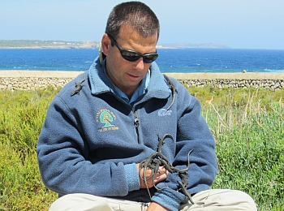
Hebrew University ecologist Dr. Dror Hawlena and friends

How do grasshoppers who are being frightened by spiders affect our ecosystem? In no small measure, say researchers at the Hebrew University of Jerusalem and at Yale University in the US.
A grasshopper who is in fear of an attacker, such as a spider, will enter a situation of stress and will consume a greater quantity of carbohydrate-rich plants – similar to humans under stress who might eat more sweets.
This type of reaction will, in turn, cause chemical changes in the grasshopper and in its excretions, affecting the ecosystem it inhabits. How does this happen?
When the scared grasshopper dies, its carcass, now containing less nitrogen as a result of its diet change, will have an effect on the microbes in the ground, which are responsible for breaking down animals and plants.
With less nitrogen available, the microbes will be decomposing the hard-to-break-down plant materials in the soil at a slower rate. Thus, the fear of predation may slow down degradation of complex organic materials to the simpler compounds required for plant growth.
Research on this biological-ecological phenomenon was carried out by Dr. Dror Hawlena of the Department of Ecology, Evolution and Behavior at the Alexander Silberman Institute of Life Sciences at the Hebrew University of Jerusalem, in cooperation with researchers at Yale University in the United States. An article on their research appears in the current edition of the journal Science.
In their research, the scientists exposed grasshoppers to spiders in order to arouse the stress reaction. They also used a control group of non-stressed grasshoppers. The scared grasshoppers had a higher carbon-to-nitrogen ratio in their bodies than non-scared grasshoppers.
In further laboratory and field tests, the researchers tested the influence of remains of grasshoppers from the two groups on soil. After the microbes consumed the grasshopper remains, the researchers added plants to the surface. In the experiments, it was shown that the decomposition rate of the plants in the areas in which the stress-free grasshopper remains were introduced decomposed at a rate between 62 and 200 percent faster than in the samples in which the stressed grasshoppers were put.
In a further experiment, the researchers used “artificial grasshoppers” – a mixture of sugar, protein, and chitin (the organic compound found in the grasshopper external skeleton) -- in varying quantities. Here, too, they found that even a small amount of nitrogen (found in the protein) added to the soil increases significantly the functioning of the microbes responsible for breaking down the organic matter in plants.
“We are dealing here with an absolutely new kind of mechanism whereby every small chemical change in a creature can regulate the natural cycle, thus in effect affecting the ecology in total, such as the amount of carbon dioxide released into the atmosphere (through decomposition) and field crop productivity. This has tremendous consequences for our ecological understanding of the living world,” said Dr. Hawlena.



Fear factor seems relevant in decomposing bug's effect on soil

The chemical composition of a dead grasshopper influences the microscopic processes below ground, study finds. And those chemicals are influenced if it's not at peace.
June 15, 2012|By Jon Bardin, Los Angeles Times
The next time you kill an insect, you might want to do it quickly — for the sake of the environment.
New research shows that whether an animal lives in safety or is terrorized by a predator can change the biochemical trajectory of the local ecosystem where it dies. The findings point to an expanded role for both predators and prey in their local environments, and may affect which species conservationists believe are most important to keep around.
The total mass of animals on the planet is puny compared with that of plants and bacteria. So researchers have long assumed that when a predator, like a spider, eats its prey, like a grasshopper, the main effect on the microbial environment is the obvious one: Fewer grasshoppers means more grass, changing the amount of plant matter available to the microscopic critters living below ground.
But a study published in Friday's edition of the journal Science shows that when a grasshopper dies, the chemical composition of its decomposing body also has a large influence on the microscopic processes going on in the area's soil. And the chemicals in the corpse are influenced by the dread of living near a killer spider.
To create a group of seriously stressed-out grasshoppers, researchers at a Yale University forest field site in Connecticut placed the bugs in an enclosure with spiders. (The spiders' mouths were glued shut, but the grasshoppers didn't know that.) This induced physiological changes in the scared grasshoppers that were not seen in a control group of grasshoppers that lived a predator-free existence, said study leader Dror Hawlena, an ecologist now at Hebrew University of Jerusalem.
"Their stress responses are very similar to humans'," Hawlena said of the grasshoppers. "They increase their metabolic rate, use more energy for maintenance, and the proteins in their bodies begin to break down."
The presence of spiders also changed the way the grasshoppers ate in a manner that mirrors the human response to stress, said Yale ecologist Oswald Schmitz, the study's senior author.
"The grasshoppers stop eating grasses, which have lots of protein, and start eating goldenrods, which contain lots of carbohydrates," Schmitz said. That's similar to how stressed-out students reach for a bag of potato chips or a box of cookies the night before exams.
This switch from a protein-rich diet to a carbohydrate-heavy one turned out to be key. Protein contains enzymes and nitrogen that help microbes in the soil break down plant matter, and this process is a crucial part of normal ecosystem function.
The researchers ground up the grasshopper corpses and mixed them with soil. After six weeks, they added dead grass and watched to see how effectively the soil was able to break it down. They found that the dirt with the remains of calm grasshoppers was far more efficient in breaking down plant matter than the dirt containing the remains of stressed grasshoppers — between 60% and 200% better.
Joshua Schimel, an expert in soil ecology at UC Santa Barbara who was not involved in the study, said the size of the effect was "head-scratching."
"The models we use to determine decomposition rates just assume that the bacteria do their job at a constant rate that isn't dependent on these types of things," Schimel said. "But our understanding is still very primitive — and the bacteria don't read our textbooks."



Scared grasshoppers change soil chemistry
Friday, 15 June 2012
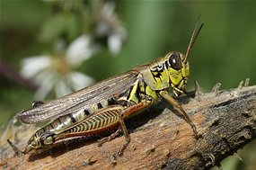
Previous research has shown that grasshoppers move to a diet of carbohydrate-rich grass to cope with stress (Source: Dror Hawlena/Hebrew University of Jerusalem)
Grasshoppers who die frightened leave their mark in the Earth in a way that more mellow ones do not, US and Israeli researchers have discovered.
"Indeed this sounds a little bit weird," says lead author Dr Dror Hawlena in an audio interview posted on the journal Science's website.
Hawlena, a researcher at the Hebrew University of Jerusalem, along with colleagues at Yale University devised a test to measure the legacy of grasshoppers who were scared by spiders.
They placed cages in areas of natural vegetation and allowed some grasshoppers to be alone while others were placed in cages with a spider.
They glued the mouths of the spiders shut in order to make sure that the grasshoppers experienced pure fear, but were not actually killed by the predators.
Previous research has shown that grasshoppers, which normally consume nitrogen-rich grass, move to a diet of carbohydrate-rich grass to cope with stress.
In their experiment, which appears in the journal Science, Hawlena and colleagues found that this resulted in the carbon to nitrogen ratio of the frightened grasshoppers changing by about four percent.
The researchers then buried the carcasses of the grasshoppers in soil containing grass litter to measure the decomposition.
They found the grass decomposed between 60 per cent and 200 per cent faster in soil containing stress-free grasshoppers compared to the stressed grasshoppers, a result they say is "huge."
"It only takes a slight change in the chemical composition of that animal biomass to fundamentally alter how much carbon dioxide the microbial pool is releasing to the atmosphere while it is decomposing plant organic matter," says co-author Professor Oswald Schmitz, of the Yale School of Forestry & Environmental Studies.
"This shows that animals could potentially have huge effects on the global carbon balance because they're changing the way microbes respire organic matter."
"What it means is that we're not paying enough attention to the control that animals have over what we view as a classically important process in ecosystem functioning." Hawlena says the findings shed light not only on how predators and prey influence the makeup of the soil, but how stresses invoked by drought and extreme heat might have lasting effects on crops and growth cycles.

Fear of spiders changes bodies of grasshoppers and makes plants decay more slowly
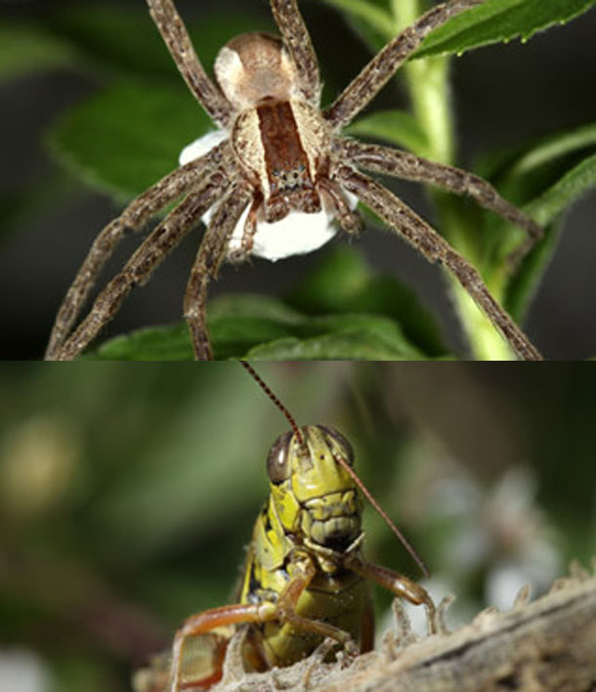
Even though most spiders are harmless to us, many people suffer from a crippling fear of them. Imagine then, what a grasshopper must feel. The threat of venomous fangs isn’t something that the insects can shrug off. It’s a perpetual danger that chemically alters their bodies, triggering changes that ripple through an entire ecosystem.
Now, Dror Hawlena from Yale University has found just how far-reaching these changes can be. In an elegant experiment, he showed that the fear instilled by spiders can extend into the very soil, affecting how quickly leaf litter decays.
Hawlena raised red-legged grasshoppers in outdoor enclosures, half a metre wide. Half the enclosures contained a single nursery-web spider, whose mouthparts had been glued shut, so they couldn’t actually kill any of the hoppers. Their presence, however, was felt.
From past studies, we know that prey animals build up stress hormones and experience higher metabolic rates when predators are around. This soaks up a lot of energy, so stressed animals tend to eat more carbohydrate-rich food, high in carbon. They also spend less energy on growing or reproducing, so they eat relatively less protein-rich food, high in nitrogen. That’s exactly what Hawlena found with his grasshoppers – the ratio of carbon to nitrogen was 4 per cent higher in the stressed insects than the unthreatened ones.
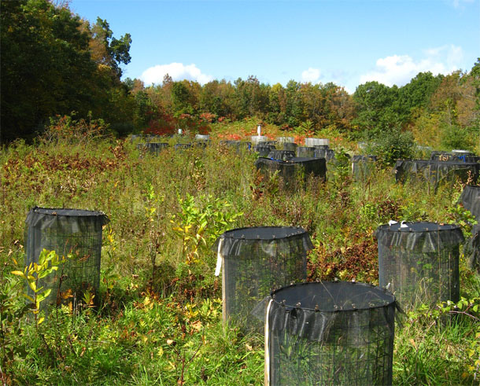
When the grasshoppers died, Hawlena buried their corpses in pots of soil within his lab, and let them decay for 40 days. He then added dead plants to the soil and used lasers to measure how quickly the carbon from their sugars and proteins was transferred into minerals or other compounds. This ‘mineralisation rate’ reflects how quickly the plants were decomposing.
After 4 months, Hawlena found that the dead plants decomposed three times more quickly in soils seeded with stress-free grasshoppers, compared to those laced with the stressed insects. The tiny difference in their chemical composition was enough to drastically impede the decay of plants that shared the same soil. When Hawlena repeated his experiment in the wild, burying the grasshoppers in field plots, he found the same results (albeit with a smaller difference in the rate of decay).
Is it plausible that such a little difference in the grasshoppers’ chemicals could produce such a big one in the plants’ decay rates? Hawlena says that even a little extra nitrogen in the soil can summon microbes that break down dead plants and animals. By providing less nitrogen, the frightened insects impeded the process of decay.
To test that idea, he created “artificial grasshoppers” – packages of chitin (the substance that makes up insect shells), sugar and proteins in roughly the same levels as in an actual insect. He varied the carbon and nitrogen in these packages to mirror those of the actual grasshoppers, but kept everything else the same. He got the same results as before: the packages meant to simulate stress-free insects slowed the decay of plant litter compared to those meant to resemble stressed ones.
Experiments like these remind us about the critical roles that predators play, and not just through killing prey animals. Their mere presence can have surprising knock-on effects. The fear and stress that they inspire aren’t just temporary states that come and go. They’re forces that are part of the natural landscape. They govern the chemical composition of living animals and the character of their environment, often in unexpected ways.



Fear Powers Zombie Bugs
Work with glued spiders and stressed grasshoppers shows how fear can transform an ecosystem even after death.
August 6, 2012
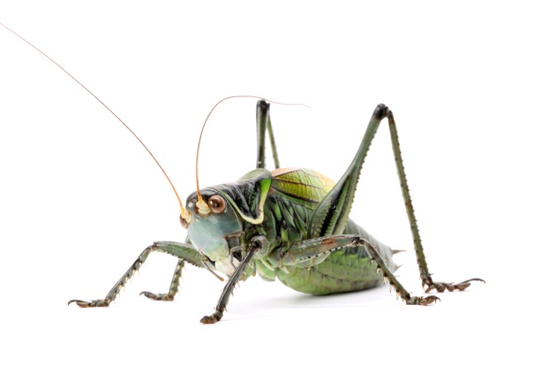
File under “Career change.” While the rest of us mopes suffer the nine-to-five in our stuffy cubicles, ecologist Dror Hawlena spends his days picking through lizard poop, gluing spiders’ mouths shut, and dissecting grasshopper guts under a microscope. He’s tracked leopards, ibexes, and wild boars. When field trips takes him out of the office, they take him waaay out of the office, to the Yale-Myers forest, the Negev Desert, Glacier National Park, the Balearic Islands, and the Wadi Rum valley, in Connecticut, Israel, Montana, Spain, and Jordan, respectively. His coworkers are guys like Acanthodactylus beershebensis and Podarcis lilfordi.
Hawlena’s research focuses on how reptiles and insects manage risk and respond to stress. He studies why lizards’ rainbowed tails lose their color (working theory: as they grow up and hunt less, they need fewer mechanisms to distract predators) and how grasshoppers become super-athletes when preyed upon by spiders.
For this last inquiry, two years ago, he raised several dozen grasshoppers in outdoor plots and then introduced spiders to half the cages, so that the hoppers either lived worry-free or in constant fear of being eaten. To prevent any casualties—Hawlena couldn’t study the athleticism of a bunch of dead grasshoppers—he carefully glued the spiders’ mouths shut with rubber cement before turning them loose in the plots. The at-risk grasshoppers—which weren’t taking any chances, rubber cement or no—quickly learned new defensive behaviors. When Hawlena staged a mini insect Olympics some months later, the congenitally stressed grasshoppers could jump faster, father, and higher than their worry-free friends.
The march of science beats steadily on. Hawlena’s newest research, which appeared in June in Science, involves more unhappy grasshoppers and sticky-mouthed spiders. In a series of three experiments, Hawlena, formerly a postdoctoral researcher at the Yale School of Forestry and now a senior lecturer at the Hebrew University of Jerusalem, and his colleagues at Yale demonstrated that stressed insects have a pronounced impact on their ecosystems—even after their deaths.
From previous work, the ecologists knew that stressed grasshoppers underwent physiological changes in response to environmental threats. At-risk hoppers have elevated metabolisms and must devote the bulk of their calories to surviving, rather than growing or reproducing; as a result, they eat less protein and more carbohydrates, which provide bursts of quick energy. This alters what ecologists call their “carbon-to-nitrogen” ratio. The body of a preyed-upon grasshopper contains a higher proportion of carbon to nitrogen, both because of its carb-intensive diet and because stress hormones cause the hopper to convert its body proteins into glucose, excreting nitrogen in the process.
The researchers discovered that this small change in grasshopper physiology—more carbon, less nitrogen—dramatically slowed the rate of decomposition in the meadows where they lived and died. After their bodies had broken down and returned to the soil, the microbial communities underfoot had a harder time processing leaf litter that fell to the ground. Hawlena theorizes that this is because nitrogen performs a critical part in decomposition processes—it primes the microorganisms that break down animal biomass (i.e. insect bodies) and plant organic matter (i.e. leaf litter) and return their minerals to the soil and air. In the test plots where the bodies of stressed, nitrogen-poor grasshoppers fell, less of the key element was available, creating a negative feedback loop: less nitrogen meant biomass was slower to decompose, shortchanging the soil microbes of even more nitrogen, ad infinitum. The consequences didn’t just ripple through the ecosystem—they amplified, too.
Hawlena and his colleagues were surprised by the finding, he told me from his office in Jerusalem. “We double and triple checked every result because it was too good to be true.” Conventional wisdom held that, given the sheer amount of vegetation growing, dying, and decomposing in the meadow, a few grasshopper bodies would be too small to have any effect on the cycle. As the authors note, the hoppers weighed 140 times less than the leaf litter added on top of them—yet they slowed its decomposition threefold. A little stress goes a long way.
Oh, and about those glued spiders … As a grown man still scarred by a childhood viewing of “Arachnophobia,” I wanted the full details. “You take the spider and, in order not to crush it, you hold it with a very soft sponge,” Hawlena explained. “Then you walk under the microscope and with a very delicate pin you just add the cement to the mouth spot. You put it close and the spider actually tries to bite it. It’s just a tiny blob.”
Apparently not everyone finds this image so delicious. Hawlena made the mistake of perusing readers’ comments on news stories that appeared in recent weeks, after the publication of the Science study. “A few of them were extremely upset with the methodology. I will not repeat the words that they used to describe me, but definitely not nice ones. Big time.”

Enriquez et al.
Freezing singularities in water drops

Physics of Fluids
2012

ScienceShot: The Sharp Shape of Frozen Water
by Gretchen Cuda Kroen on 12 October 2012, 3:04 PM
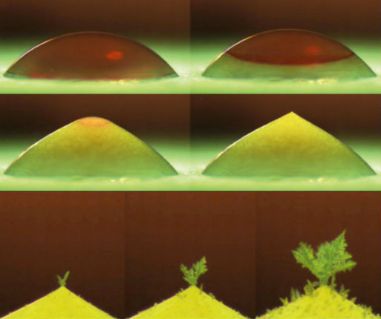
Credit: Oscar R. Enríquez, Álvaro G. Marín, Koen G. Winkels, and Jacco H. Snoeijer, Physics of Fluids Group, University of Twente, Enschede, The Netherlands
Frozen water droplets take on a whole new shape when they freeze: Instead of staying round, they form a pointy tip, and eventually sprout a tiny forest of ice crystals on their surface. In order to observe these effects, researchers dripped tiny beads of water on a plate kept at a chilly -20°C. In the 18 seconds that it took the 4-millimeter-diameter droplets (top row) to solidify, researchers snapped photos of the water freezing from the bottom up. During the final stage of freezing, the ice drops developed a pointy tip (middle row), which continued to grow and eventually formed delicate ice crystals on the surface, the team reported last month in Physics of Fluids. Researchers believe the unusual pointy tip is caused by the vertical expansion of the ice combined with the surface tension on remaining liquid. Once frozen, the sharp tip of the drop attracts water vapor from the air, and produces treelike ice crystals (bottom row).
American Institute of Physics headline: Freezing water droplets form sharp ice peaks
The Daily Mail (UK) headline: Frozen in time: the pictures that reveal the ‘tree’ created when ice forms on a single droplet of water



Freezing Water Droplets Form Sharp Ice Peaks
Released: 10/5/2012 9:00 AM EDT
Source: American Institute of Physics (AIP)
Researchers at the University of Twente, in the Netherlands, placed water droplets on a plate chilled to -20 degrees Celsius and captured images as a freezing front traveled up the droplet. The photos are published in the American Institute of Physics’ (AIP) journal Physics of Fluids. The approximately 4-millimeter diameter droplets took about 20 seconds to freeze. During the final stage of freezing, the ice drop developed a pointy tip, as can be seen in Figure 1d. The effect, which is not observed for most other liquids, arises because water expands as it freezes. The vertical expansion of the ice, in combination with the confining effect of surface tension on the spherical cap of remaining liquid, leads to the point formation.
Once the liquid is completely frozen, the sharp tip of the drop attracts water vapor in the air, much like a sharp metal lightning rod attracts electrical charges. The water vapor collects on the tip and a tree of small ice crystals starts to grow, as seen in Figure 2. An opposite effect has been shown to preferentially extract water molecules from the sharp edge of potato wedges in the oven, the researchers note.



Frozen in time: The pictures that reveal the 'tree' created when ice forms on a single droplet of water
PUBLISHED: 11:48 EST, 8 October 2012 | UPDATED: 11:49 EST, 8 October 2012
These incredible pictures capture the moments water freezes.
They show an ice ‘tree’ growing on a single droplet of water.
The beautiful phenomenon was captured on video by scientists who placed the globule on a plate cooled to -20C and watched as it froze.
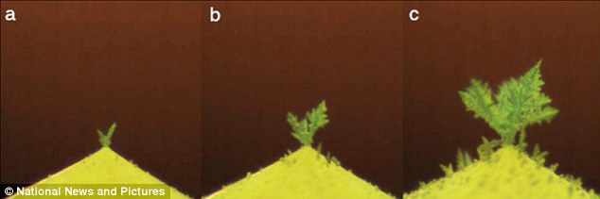
An ice 'tree' growing on a single droplet of water. The beautiful phenomenon was captured on video by scientists from Twente University in Holland who placed the globule on a plate cooled to -20C and watched as it froze.
In liquid form drops of water have a spherical shape, but when they freeze they become angular with a point at the top.
Physicist Oscar Enriquez, of Twente University in Holland, said: 'The process of solidification can be observed very clearly due to the change in refraction when water turns into ice.'
When light passes into a denser substance - such as from air to water - it is refracted or ‘bent’ towards a line forming a 90 degree angle to the boundary between the two substances.
The bending occurs because light travels more slowly in a denser medium.
The film shows the drop freezes from the bottom up where it is in contact with the cold plate and stays more or less spherical while the water at the top is still runny.
But as the final part of the liquid freezes the surface is pushed up by the water - causing a point to form at the top of the ‘mountain’.
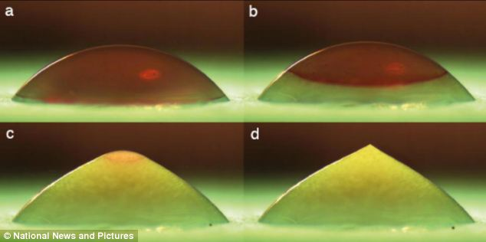
The close up camera captures water changing shape as it freezes. In liquid form drops of water have a spherical shape, but when they freeze they become angular with a point at the top.
But then something unexpected happens - the sharp tip of the ice drop attracts water vapour in the air much like a sharp metal lightning rod triggers electrical charges.
This collects and a tiny tree of small ice crystals starts to grow, the photos published in Physics of Fluids show.
The researchers said the effect is not observed for most other liquids and arises because water expands as it freezes.
The vertical growth in combination with the confining effect of surface tension on the spherical cap of remaining liquid leads to the point formation.
An opposite effect has been shown to extract water molecules from the sharp edge of potato wedges in the oven.

Dyer et al.
Parallel evolution of angiosperm colour signals: common evolutionary pressures linked to hymenopteran vision

Proceedings of the Royal Society
2012

ScienceShot: Bees' Flower Power
by Sarah C. P. Williams on 5 June 2012, 7:01 PM |

Credit: Sue Williams and Adrian Dyer
Bees are a flower's best friends: The insects land on flowers that catch their eye, pick up pollen with their sticky feet, and spread the plants' genetic material far and wide. Scientists have even shown that, in the Northern Hemisphere, flowers' coloring patterns evolved specifically to meet the nuances of insect vision. To test whether the evolutionary link between flowers and insects holds true in Australia, which has been geographically isolated for 34 million years, scientists collected 111 native Australian flowers. They analyzed the color patterns—not just in the spectrum of visible light that humans can see, but also the reflection of ultraviolet light that insects are sensitive to. The yellow jessamine (Gelsemium sempervirens, above), for example, appears entirely yellow to humans but has broad color variation to bees. Echoing previous studies from the northern part of the world, the Australian data, published today in the Proceedings of the Royal Society B, shows that flowers Down Under show the most color variance in the narrow spectra that insects are most sensitive to. This helps an insect distinguish flowers, remember their favorite, and return to it—good news for the plant. The results, now replicated on two continents, likely hold true elsewhere as well.
Monash University headline: Bees the key to flower colour evolution
ABC Science (Australia) headline: Aussie bees drove flower evolution
Sydney Morning Herald headline: Prime pollinators are bees knees when it comes to colors


Bees the key to flower colour evolution

7 June 2012

Photographic reconstruction of how bee vision would see a flower, which appears yellow to human eyes.
Plants separated by vast oceans and 34 million years evolved to produce the same coloured flower petals because of their reliance on bees for pollination, according to new research.
In a study published today in the Proceedings of the Royal Society B, scientists from Monash University, RMIT University and the Swedish Museum of Natural History demonstrated how flowering plants, or angiosperms, in Australia and Europe have made use of the same colours to attract bees.
Lead researcher Dr Adrian Dyer of Monash University's Department of Physiology and RMIT's School of Media and Communications worked with Monash colleagues Dr Bob Wong, Sky Boyd-Gerny and Vera Simonov from the School of Biological Sciences, and Professor Marcello Rosa, also from the Department of Physiology on the study.
Dr Dyer said Australia was a good subject for studying flower evolution because it separated from other continents 34 million years ago.
"Australia's long-term isolation means that species of plants here and in Europe independently evolved to have similarly coloured petals," Dr Dyer said.
"Our research shows that the common factor here is the known colour vision discrimination abilities of bees. The plants have, over time, developed petals that will attract bees to act as pollinators."
The research showed that certain plants have optimised their petal colours to be easily perceived by bees. Over time, bees have the capacity to learn to associate these flowers with food.
"Bees have trichromatic vision based on ultraviolet, blue and green photoreceptors, so what they see is very different from what we see. However, bees from around the world all appear to have very similar colour vision," Dr Dyer said.
"Previous research has determined that colour vision present in modern bees actually evolved before angiosperms, meaning the plants probably adapted their flower colour to take advantage of pre-existing conditions."
Bees tend to be 'flower constant', repeatedly visiting one type of plant if it continues to provide food. Taking advantage of this to maximise bee visits is an efficient way for plants to ensure that pollen is distributed to others in their species, rather than relying on random wind distribution.
"Currently there is little known about plant-pollinator relationships in Australia; this work shows just how important bees have been to influencing flower colour evolution on this enormous island continent," Dr Dyer said.

Aussie bees drove flower evolution
Tuesday, 5 June 2012 | Fiona MacDonald

The colours emitted by Australian flowers directly correlated to the bee's vision receptors (Source: S Williams, A Dyer )
Flowers in Australia evolved their bright colours to attract native bees, according to new research that proves the flying insects are crucial to flower pollination around the world.
Researchers already knew that flower colours in the Northern Hemisphere were targeted to bee vision, but a new study in Proceedings of the Royal Society B is the first to show bees were also the main drivers in the colour evolution of Australian flowers.
The fact that the same process occurred in Australia, even though the continent has been geographically isolated for more than 34 million years, suggests that bees are the most important pollinators for flowers, says lead author Adrian Dyer, a vision researcher from Monash University in Melbourne.
"We now know for sure that bees have been the major driver of flower colours around the world, more than birds or butterflies, and are a very important resource to protect," he says.

Main pollinators
Before Australia broke away from the other continents, about 34 million years ago, fossil evidence suggests flowering plants were simple, plain structures without pigment, says Dyer.
However, since then many brightly coloured and interestingly shaped flowers have evolved on the island continent as a result of the pressure to attract pollinators.
To determine whether birds, butterflies or bees drove this evolution, Dyer and his team randomly sampled 111 species of Australian native flowers and, using a spectrophotometer, examined which of the pollinators could detect their colours.
They found that the colours emitted by Australian flowers directly correlated to the bees' ultraviolet-, blue- and green-receptors.

Parallel evolution
Researchers have found the same link between flowers and bee vision in the Northern Hemisphere, showing that the same process occurred independently on two different continents, which is known as parallel evolution, says Dyer.
The bees that shaped the evolution of Australian flowers were stingless, native bees, not species such as honeybees that would have been present in the Northern Hemisphere.
But Hymenoptera (the order of insects that includes bees) all detect colour in an extremely similar way - which is proof that flowers evolved to suit their main pollinator, and not the other way around, according to Dyer.
"We know that bees' ability to detect colour links back to a common ancestor around 300-400 million years ago, and there's no evidence at all that bee vision has tuned since then to suit flower colours - it's been a one-sided evolution in both the Northern Hemisphere and Australia," he said.
According to Dyer, this research restates how important it is to protect our bees, particularly given the recent decline in numbers in Europe and the US.
"The study shows there are wide economical and environmental implications for looking after bees - they're absolutely essential for the pollination of flowering plants."



Prime pollinators are bees knees when it comes to colours
June 12, 2012
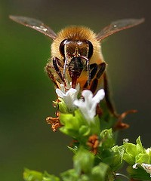
THE power of the prime pollinator has been revealed, with research showing native bees have determined the colour of Australian flowers.
The findings, published in Proceedings of the Royal Society B, show Australian flowering plants have evolved to match the colour vision capabilities of native bees over other key pollinators such as birds and butterflies.
The findings mirror results from European studies and are an important proof of concept because Australian flora and fauna evolved in isolation over 34 million years.
''We now know that this is a general principal that can be applied across the world,'' said Adrian Dyer from RMIT University, the lead author on the paper with scientists from Monash University and the Swedish Museum of Natural History.
Dr Dyer said researchers were able to establish the bee was the preferred pollinator because the flower colours that have most frequently evolved in Australia fit only to the colour discrimination of bees, not birds or butterflies.
More than 110 different native plant species were used in the study, collected from Balwyn's Maranoa Gardens in Victoria over eight months from May 2009. A UV photograph was taken of a flower from each plant and the colours analysed to see which of the pollinators could detect their colours.
Australian native bees have UV, blue and green colour photoreceptors, as do their northern hemisphere honey bee relations. There are two classes of birds: one that sees UV blue, green and red, and the other, which sees UV violet, blue, green and red. Humans have blue, green and red photoreceptors.
Dr Dyer said while a flower appeared yellow to humans, the same flower appeared pink with a red centre to bees. It would look different again to birds.
''Flowers look more dazzling to insect pollinators because they have evolved spectoral signals to best suit bees,'' Dr Dyer said. ''Bees see a two-coloured flower because the petals reflect ultraviolet and the inner part doesn't.''

Worm et al.
Global catches, exploitation rates, and rebuilding options
for sharks

Marine Policy
2013

ScienceShot: The Great Shark Massacre
by Erik Stokstad on 1 March 2013, 1:15 PM
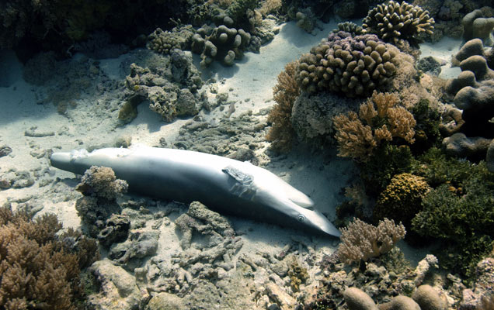
Credit: Nancy Boucha
Sharks have become the underdog of the oceans. They reproduce slowly and are being targeted for their fins and caught accidentally in the hunt for fish. Now, researchers have created the first global estimate of the carnage. By combining data from fisheries organizations and the scientific literature, the team reports in Marine Policy that 97 million sharks were killed in 2010 and perhaps as many as 273 million. "This is the best attempt, published to date, to bring together the available data to quantify fisheries impacts on sharks at a global scale," says John Musick, a shark expert at the Virginia Institute of Marine Science in Gloucester Point. The dire figure implies that more sharks are being taken than are born, jeopardizing their future. George Burgess of the Florida Museum of Natural History in Gainesville points out that the calculation required numerous assumptions, including a single weight estimate for all sharks. Nevertheless, Burgess says, experts agree that sharks are in deep trouble. "It's just a matter of how bad off." The authors argue that sharks need stronger protections, such as the kind of international agreement that has protected whales, or restrictions to the trade of their fins and meat. Several such proposals will be considered this month as the Conference of the Parties to the Convention on International Trade in Endangered Species of Wild Fauna and Flora meets in Bangkok.

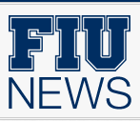
Fishing leads to significant shark population declines, researchers say
By JoAnn Adkins, 03/01/2013
The world’s shark population is experiencing significant decline with perhaps 100 million or more sharks being lost every year, according to a study published this week in Marine Policy.
While sharks are one of the oldest vertebrate groups on the planet, the population decline is causing global concern.
In the recently published paper, “Global Catches, Exploitation Rates and Rebuilding Options for Sharks,” researchers from Dalhousie University and University of Windsor in Canada, as well as Stony Brook University in New York, FIU and the University of Miami calculate total shark mortality and outline possible solutions to protect the world’s shark population.
“This is a big concern because the loss of sharks can affect the wider ecosystem,” said Mike Heithaus, executive director of FIU’s School of Environment, Arts and Society and co-author of the paper. “In working with tiger sharks, we’ve seen that if we don’t have enough of these predators around, it causes cascading changes in the ecosystem, that trickle all the way down to marine plants.”
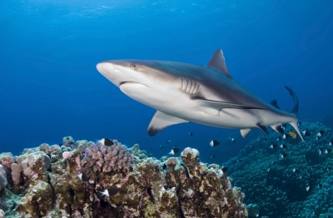
Such changes can harm other species, and may negatively affect commercial fisheries, according to Heithaus, who also serves as a Marine Sciences professor in the Department of Biological Sciences. Based on data collected for the latest study, shark deaths were estimated at 100 million in 2000 and 97 million in 2010. The total possible range of mortality is between 63 and 273 million annually.
The biggest culprit in the significant population decline is a combination of a global boom in shark fishing — usually for their valuable fins — and the relatively slow growth and reproductive rates of sharks. Because adequate data of shark catches is lacking for most of the world, the wide range of possible mortality is based on available data of shark deaths and calculated projections for unreported, discarded and illegal catches. But even with the uncertainty there is little question that sharks are being caught faster than they can reproduce.
“Sharks are similar to whales, and humans, in that they mature late in life and have few offspring’ said Boris Worm, lead author and professor of biology at Dalhousie. “As such, they cannot sustain much additional mortality. Our analysis shows that about one in 15 sharks gets killed by fisheries every year. With an increasing demand for their fins, sharks are more vulnerable today than ever before.”
While some sharks are receiving protection through national and international agreements, the team of researchers suggests legislation should be expanded to a greater number of species. Imposing a tax on the export and import of shark fins could also help curb demand and generate income for domestic shark fisheries management, according to the study. Catch limits, trade regulations and other protective measures for the most vulnerable species can also help.
The key message in this research is sustainability. Because of the role sharks play in the sustainability of marine ecosystems, the researchers insist that protective measures must be scaled up significantly to avoid further depletion and possible extinction of some of the world’s top predators.
The information from this report comes at a critical time, as 177 governments from around the world will attend the March 3-14 meeting of the Conference of the Parties to the Convention on International Trade in Endangered Species of Wild Fauna and Flora (CITES) in Bangkok. CITES is widely considered one of the best tools for protecting vulnerable species from extinction.
From: http://news.fiu.edu/2013/03/100millionsharks/52935

100 million sharks killed each year, say scientists
Protect sharks or they face possible extinction in a generation, scientists warn as they gather in Bangkok for Cites meeting
Friday 1 March 2013 14.01 EST
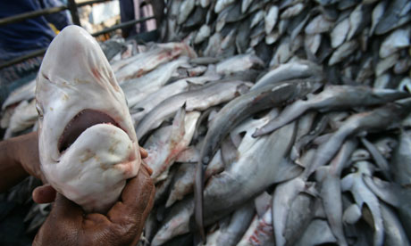
A truck full of sharks heading to market to be finned in the red sea port of Hodeidah, Yemen. Photograph: Paul Hilton/EPA
Almost 100 million sharks are being killed each year, with fishing rates outstripping the ability of populations to recover, scientists have estimated.
Sharks need better protection to prevent possible extinction of many species within coming decades, the researchers warned ahead of latest global meeting to discuss the trade in threatened species.
The Convention on International Trade in Endangered Species (Cites) meeting, starting on Monday in Bangkok, will consider greater protection of vulnerable sharks, including porbeagles, oceanic whitetip and three types of hammerhead to prevent unsustainable international trade in them.
Sharks are targeted for their fins for use in shark fin soup, a delicacy in Asia.
But as they are slow-growing and slow to reproduce, they are vulnerable to overfishing. The researchers estimated that global reported catches, unreported landings, discards and sharks caught and thrown back after their fins were cut off – a process known as finning – added up to 97 million fish caught in 2010.
The figure is only slightly down on the estimated 100m caught in 2000, and could be anywhere between 63 million sharks and 273 million a year, the research by North American scientists published in the journal Marine Policy said.
It is estimated that between 6.4% and 7.9% of all sharks are being killed each year, above the level that many populations can cope with, leading to declines in a number of species.
Lead author Boris Worm, from Dalhousie University in Halifax, said: "Biologically, sharks simply can't keep up with the current rate of exploitation and demand.
"Protective measures must be scaled up significantly in order to avoid further depletion and the possible extinction of many sharks species in our lifetime."
Although some regions, including the European Union, have banned shark finning, commercial fisheries for fins, meat, liver oil, cartilage and other body parts is largely unregulated in much of the world, conservationists warn.
Under the proposals put forward for consideration by the Cites meeting, five shark species would be listed as Appendix II which would ensure that any international trade in them is sustainable and legal. A previous attempt to have the trade in some species of shark monitored and regulated under the Cites treaty narrowly failed, but conservation charity Pew Environment Group believes there is a great deal of momentum behind the latest bid.
Elizabeth Wilson, manager of global shark conservation at Pew, said the proposals had broad support across developed and developing countries and campaigners were hopeful that something positive could come from the meeting.
She said the study published today showed that people were killing an "enormous" number of sharks.
"We are now the predators. Humans have mounted an unrelenting assault on sharks, and their numbers are crashing throughout the world's oceans."
But she said: "A simple vote 'yes' to support their listing could turn things around for some of the world's most threatened shark species. Countries should seize this opportunity to protect these top predators from extinction."
The Cites meeting is also considering protection for manta rays, which are being fished for their gill plates that are sold in China as medicine claimed to treat a range of health complaints from asthma to chicken pox and even cancer.
The trade is on the increase, with Mozambique recording an 86% decline in sightings of the fish over the last eight years, Ms Wilson said.
But manta rays are very important in eco-tourism, providing a major draw for divers who will pay a lot to see them, she added, raising hopes countries will want to protect them.
From: http://www.guardian.co.uk/environment/2013/mar/01/100-million-sharks-killed-each-year

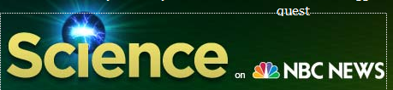

Pity for a predator: 100 million sharks die each year, conservationists say
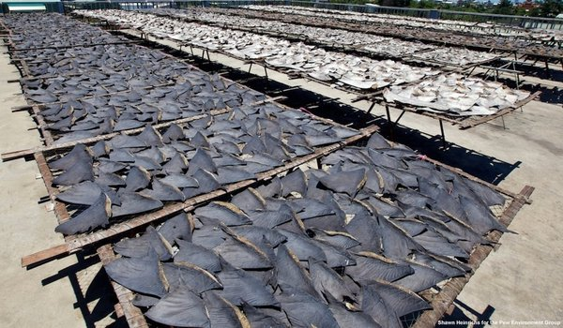
Shawn Heinrichs for Pew Environment Group
Shark fins dry in the sun in the Taiwanese city of Kaohsiung before processing. Thirty percent of the world's shark species are threatened or near threatened with extinction.

By Megan Gannon LiveScience
March 2, 2013
Aggressive overfishing threatens to push some shark species to extinction, and a new study puts annual shark deaths at 100 million.
"Our analysis shows that about one in 15 sharks gets killed by fisheries every year," study leader Boris Worm, a professor of biology at Canada's Dalhousie University, said in a statement. "With an increasing demand for their fins, sharks are more vulnerable today than ever before."
Based on available data for shark deaths and estimates of unreported illegal catches, the researchers estimated that 100 million sharks were killed in 2000 and 97 million in 2010. But since scientists lack sufficient data on shark catches, they say the real number of annual shark deaths could possibly be between 63 million and 273 million.
Sharks are fished for their meat, liver oil, cartilage and valuable fins, which are hacked off, often from live sharks, to be used in shark fin soup, an ancient and prized delicacy in East Asia. Since sharks have slow growth and reproductive rates, it can be tough for their populations to bounce back from big losses.
Conservationists say the depletion of shark populations is concerning because as apex predators, they help balance ecosystems in the world's oceans. [On the Brink: A Gallery of Wild Sharks]
"In working with tiger sharks, we've seen that if we don't have enough of these predators around, it causes cascading changes in the ecosystem, that trickle all the way down to marine plants," said study researcher Mike Heithaus, a Florida International University biologist.
On March 3, hundreds of delegates from 177 different countries will descend on Bangkok for the meeting of the Convention on International Trade in Endangered Species of Wild Fauna and Flora, or CITES. On the agenda will be increased trade protection for five species of sharks — the oceanic whitetip, porbeagle and three types of hammerheads — which are hunted for their fins.
"A simple vote 'yes' to support their listing could turn things around for some of the world's most threatened shark species," Elizabeth Wilson, manager of global shark conservation at the Pew Charitable Trusts' environmental organization, said in a statement. "Countries should seize this opportunity to protect these top predators from extinction."
Sharks have a PR problem that might be hurting their chances of survival. A study out last year found that a majority of the media coverage they get involves shark attacks on humans, which doesn't reflect how rare these scary encounters are. In 2012, there were 80 confirmed shark attacks worldwide, but only seven of them were deadly, according to the University of Florida's International Shark Attack File.
The new research was detailed online in the journal Marine Policy.
From: http://science.nbcnews.com/_news/2013/03/02/17162143-pity-for-a-predator-100-million-sharks-die-each-year-conservationists-say?lite



Fishing is pushing sharks closer to extinction
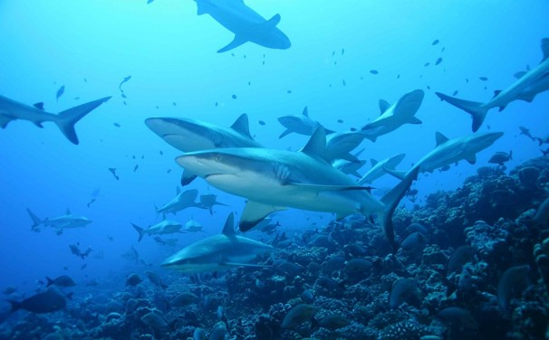
View Photo Gallery — A new study shows shark mortality is substantially higher than previously thought. Ocean sanctuaries offer protection for sharks: French Polynesia and the Cook Islands created adjacent shark sanctuaries last year, spanning 2.5 million square miles of ocean, a move that reflects a growing trend to protect sharks worldwide.

Published: March 1
New study estimates that commercial fishing kills 100 million sharks annually
Commercial fishing kills roughly 100 million sharks a year, a toll that is pushing many of species of the fish closer to extinction, according to a study published Friday in the journal Marine Policy.
The new estimate by Canadian and American researchers — the most comprehensive analysis yet of global shark mortality — is substantially higher than numbers found in previous studies, in part because it takes into account the impact of illegal catches and discarded sharks. It comes as international negotiators are about to gather in Bangkok starting Sunday to debate whether to impose new trade restrictions on several imperiled shark species.
Sharks are being fished at an average rate that is 30 to 60 percent higher than they can sustain, the scientists conclude, noting that the animals take years to sexually mature and produce their small litters. Sharks are primarily targeted for their fins, which are used in the Asian delicacy shark’s fin soup, though they are also caught accidentally by vessels seeking tuna, swordfish and other species.
The analysis, based on a survey of roughly 100 papers, suggests that despite several efforts to curb shark finning worldwide, the total number of shark deaths has declined only slightly between 2000 to 2010, from 100 million to 97 million.
“It is not sustainable,” said Dalhousie University biology professor Boris Worm, the paper’s lead author, noting that sharks have roamed the seas for more than 400 million years. “Imagine we still had 500 species of dinosaurs around — every form and color from tiny critters to huge, whalelike creatures. Once they were everywhere, but then we started to chop off their tails to make soup from it, and now they are going extinct — not because a meteorite hit the planet, but because we ate their tails.” Elizabeth Wilson, manager of global shark conservation at the Pew Environment Group, said she hoped delegates to the Convention on International Trade in Endangered Species of Wild Fauna and Flora (CITES) over the next two weeks would act on the findings and restrict the trade of oceanic whitetip, porbeagle and three types of hammerhead sharks. “The number of sharks being killed is too high,” Wilson said. “There’s an opportunity at CITES to do something to help shark species.”
— Juliet Eilperin
From: http://www.washingtonpost.com/national/health-science/fishing-is-pushing-sharks-closer-to-extinction/2013/03/01/8dd88eac-81e4-11e2-8074-b26a871b165a_story.html



100 Million Sharks Killed Every Year, Study Shows On Eve of International Conference on Shark Protection
Posted by Dan Stone of National Geographic Magazine in Ocean Views on March 1, 2013
One of the most comprehensive studies ever compiled on illegal shark killing brings new startling statistics. An estimated 100 million sharks are killed every year around the world, a number that far exceeds what many populations need to recover.
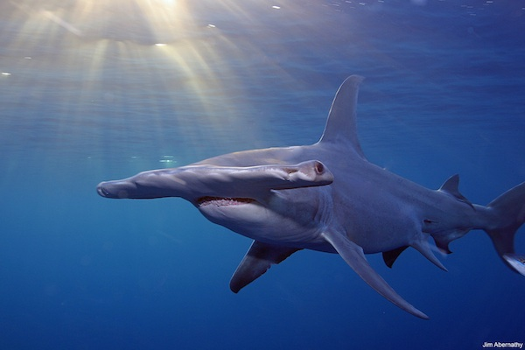
The statistical report, compiled by researchers at Dalhousie University in Halifax, Canada, crunched numbers of reported shark catches globally and used data from nearly 100 former papers to estimate the number of unreported shark deaths every year. In a moving range, the researchers were able to calculate that between 6.4% and 7.9% of sharks of all species are killed annually.
Hammerhead sharks are particularly at risk. Photo by Jim Abernaty / Pew Environment Group
To put that range in perspective, researchers analyzed life data from 62 shark species and found that only 4.9% of sharks can be killed each year to maintain population stability. Anything more than that threatens long term survival of species like the oceanic white tip, porbeagle and several kinds of hammerheads. What’s worse, sharks are considered uniquely vulnerable because they take long periods to mature and generally produce few young over their lifetimes.

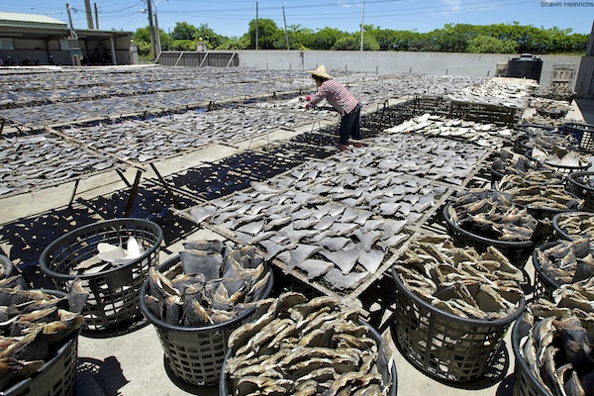
Photo by Shawn Heinrichs / Pew Environment Group
The culprit is the proliferation of illegal shark finning that spiked in the 1990s to feed appetites for shark fin soup, a delicacy in parts of Asia on par with fine truffles or expensive caviar. According to some reports, a bowl of shark fin soup can sell for as much as $100.
While some sharks are allowed to be caught, illegal shark finning occurs when fisherman cut fins off live sharks and dump their bodies into the open ocean to avoid declaring the full animal at port and surpassing fishing quotas.
“There’s a staggering number of sharks being caught every year and the number is way too high considering the biology of species,” says Dalhousie biologist Boris Worm, the study’s lead researcher. The 100 million sharks was actually a conservative estimate. Worm’s team found the number could be as high as 273 million sharks killed each year.
To combat such numbers, most countries have authority to regulate around their own coastlines and the catches brought into their ports. But pressure has grown over the past few years for the Conference on International Trade of Endangered Species (CITES) to regulate international trade of the most imperiled species. As recently as 2010, CITES officials denied meaningful protections to sharks. But after a United Nations panel recommended earlier this year that governments get serious, CITES officials will meet this week in Bangkok to consider finally phasing in protections.
From: http://newswatch.nationalgeographic.com/2013/03/01/100-million-sharks-killed-every-year-study-shows-on-eve-of-international-conference-on-shark-protection/

Middleton et al.
Grizzly bear predation links the loss of native trout to the demography of migratory elk in Yellowstone

Proceedings of the Royal Society – Biological Sciences
2013

ScienceShot: Grizzlies Lose Important Food Source in Yellowstone
by Virginia Morell on 14 May 2013, 7:01 PM
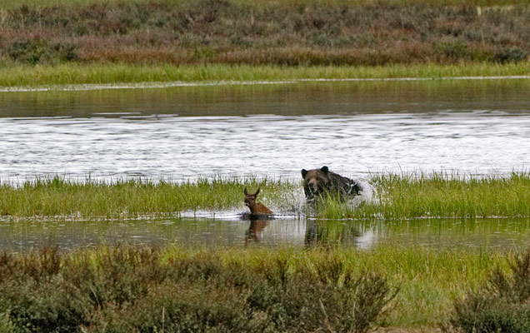
Credit: Bruce H. Oakley
What do grizzly bears in Yellowstone National Park eat? Comedians are likely to answer: Whatever they want. But what they want—native Yellowstone cutthroat trout—are struggling, thanks to the illegal introduction of non-native lake trout in the 1980s by fishers. The bigger lake trout have been feasting on the cutthroat variety, and now there simply aren't enough of the latter for the bears, which dine on the cutthroats when they spawn in shallow waters. The lake trout don't provide an alternative food source, because they spawn at depths that are inaccessible to the bears. So, the grizzlies have increasingly turned to a different, but equally nutritious prey item: elk calves. These days, the bears spend far less time prowling the shores of Yellowstone Lake and streams for trout, and instead hunt the calves, as in the photo above. In a study this week in the Proceedings of the Royal Society B, researchers report that their simulations of elk demographics indicate that the grizzlies' dietary switch is a surprising factor in the park's elk population decline. Especially hard-hit are the migratory elk that spend summer around Yellowstone Lake and winter in valleys outside the park. The team modeled the bears' new diet, and they concluded that every year, the grizzlies are likely reducing the number of calves reaching maturity by 4% to 16% and the herds' overall population growth by 2% to 11%. Wolves, which were reintroduced to the park in 1995, have been blamed for the elks' dropping numbers by some scientists and ranchers around Yellowstone. But wolves, which also hunt adult elk, may play a smaller role than previously thought. The elks' troubles are more likely the fault of the bears, the lake trout, and ultimately the humans who introduced the fish to the ecosystem in the first place.

NEWS

New UW Research Shows Grizzly Diet Shift Hits Elk Herds
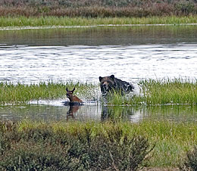
May 15, 2013 — A decline in native Yellowstone cutthroat trout due in part to the introduction of nonnative lake trout has driven a shift in the diets of grizzly bears that helps explain losses in some migratory elk herds in the greater Yellowstone area, according to new research published today.
The article in the Proceedings of the Royal Society B, led by recent University of Wyoming Ph.D. graduate Arthur Middleton along with numerous collaborators, provides further support for efforts by Yellowstone National Park to suppress the lake trout population in Yellowstone Lake, those researchers say.
“This synthesis suggests that, even in a core wilderness area like Yellowstone, a fisherman’s blunder in the aquatic system many years ago can have far-reaching effects by forcing an omnivorous predator to seek new foods in the terrestrial landscape,” Middleton says. “These surprisingly broad ecological consequences underscore the importance of identifying new methods to suppress lake trout and the value of preventing such invasions elsewhere.”
Over nearly two decades, monitoring has shown a dramatic drop in the numbers of native cutthroat trout that inhabit Yellowstone Lake and spawn in its tributaries, largely as a result of the illegal introduction of lake trout -- which prey on cutthroats and spawn at depths inaccessible to bears. Other factors in the decline of cutthroats are thought to be drought and whirling disease. The lake trout invasion is believed to have influenced the foraging of many birds and mammals, but its cascading ecological effects have only come to light more recently.
Historically, spawning cutthroat trout were documented as an important seasonal food source for as many as 70 of Yellowstone’s grizzly bears. Recent studies by researchers at Washington State University, however, now indicate that female grizzlies have turned to elk calves -- which are born at the same time of year when cutthroat spawn -- to replace the loss of fish in their diet.
Meanwhile, state wildlife agencies in Wyoming, Montana and Idaho have observed significant declines in some elk herds that spend summers in high-elevation areas of Yellowstone and migrate to valleys 25-85 miles outside the park for the winter. Specifically, cow-calf ratios in these migratory herds have dropped significantly, and the new research shows that summer predation -- likely by grizzlies -- is thinning the crop of elk calves even before the herds begin their fall migrations out of the park.
While drought and the sheer increase in numbers of wolves and grizzlies also have contributed to the decline of elk herds in the greater Yellowstone area, the new research shows that prey switching by grizzlies due to the loss of cutthroat trout also is “capable of creating meaningful changes in the population dynamics of migratory elk.” Grizzlies specialize in killing elk calves in the first few weeks of life, whereas wolves tend to hunt them later in the fall and winter -- which means that intense grizzly predation can pre-empt the effect of wolves on calf numbers.
“Our work suggests that important effects of human disturbance and grizzly bear predation on migratory elk are being overlooked,” the report says. It adds that the shift in grizzly diets from cutthroat trout to elk calves “is uniquely important to research and management because it represents a novel, human influence operating cryptically within core protected areas” of Yellowstone.
While at UW, Middleton worked under Matt Kauffman, head of the Wyoming Cooperative Fish and Wildlife Research Unit and assistant professor in the Department of Zoology and Physiology. Middleton is now a post-doctoral fellow at the Yale School of Forestry and Environmental Studies.
Kauffman, a U.S. Geological Survey scientist, is one of the co-authors of the report published today -- along with a collaborative team of researchers from Washington State University, Iowa State University, Yellowstone National Park, the Wyoming Game and Fish Department, and Montana Fish, Wildlife & Parks.
To view the full report in the Proceedings of the Royal Society B, go to: http://rspb.royalsocietypublishing.org/gca?submit=Get+All+Checked+Abstracts&gca=royprsb%3B280%2F1762%2F20130870.
For more information, lead researcher Arthur Middleton may be reached at (307) 460-0880 or arthur.middleton@yale.edu.
Photo:
A grizzly bear chases an elk calf in Yellowstone National Park near Mammoth, Wyo., in 2009. New research shows that prey switching by grizzlies due to the loss of cutthroat trout is “capable of creating meaningful changes in the population dynamics of migratory elk” in the greater Yellowstone area. (Bruce H. Oakley Photo)
From: http://www.uwyo.edu/uw/news/2013/05/new-uw-research-shows-grizzly-diet-shift-hits-elk-herds.html




May 21, 2013 2:54 pm

Bears That Have No Fish to Eat Baby Elk Instead
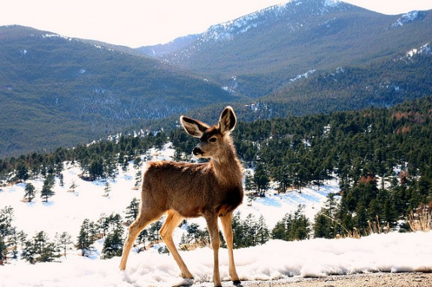
Dawww. Photo: aaronz
Yellowstone National Park is a vast expanse of largely-untouched natural beauty, a tract of the west home to bears and wolves and geysers and mountains. But where humankind’s direct influence is deliberately kept to a minimum, that strategy of do-no-harm doesn’t always seem to work. For the past few decades, lake trout have been taking over the rivers and lakes in Yellowstone, pushing out the local Yellowstone Cutthroat trout. The Greater Yellowstone Coalition:
Yellowstone Lake and its tributaries once supported an estimated 3.5 million Yellowstone cutthroat trout. Since the illegal introduction of lake trout in the 1980s, the cutthroat population in Yellowstone Lake has plummeted. Catch rates for Yellowstone cutthroats have significantly dropped as more and more lake trout are caught every year. The precipitous drop in cutthroat numbers is a result of lake trout predating on cutthroat trout.
But more than just affecting cutthroat trout, the invasion of the lake trout is being felt throughout the ecosystem. According to new research lead by Yale’s Arthur Middleton, the replacement of cutthroat trout with lake trout is leaving Yellowstone’s local population of grizzly bears without enough fish to eat. Middleton and colleagues:
Historically, Yellowstone Lake harboured an abundant population of cutthroat trout, but lake trout prey heavily on cutthroat trout and have driven a decline of more than 90 per cent in their numbers. Although cutthroat trout migrate up shallow tributary streams to spawn, and are exploited by many terrestrial predators, lake trout spawn on the lake bottom and are inaccessible to those predators.
Without fish, the grizzlies need something, and in their place the bears have turned to eating baby elk.
In the late 1980s, grizzly and black bears killed an estimated 12 per cent of the elk calves in northern Yellowstone annually. By the mid-2000s, bears were estimated to kill 41 per cent of calves.
The researchers say that by turning to elk calves in place of the now-gone trout, the elk population growth rate has shrunk by 2 to as much as 11 percent. The research reminds that the food web is in fact a web, and that the illegal introduction of a few trout can mean a whole lot of dead elk.
From: http://blogs.smithsonianmag.com/smartnews/2013/05/bears-that-have-no-fish-to-eat-eat-baby-elk-instead/

Grizz blamed in elk decline
Yellowstone bears eating elk calves in place of spawning cutthroat.

By Angus M. Thuermer Jr., Jackson Hole, Wyo.
May 15, 2013
A paper published Tuesday says invasive cutthroat-eating lake trout in Yellowstone Lake have caused grizzly bears to shift their diet, resulting in a decline in Yellowstone National Park’s elk calves.
Cutthroat trout that spawned during spring in shallow tributaries of the lake used to make up a substantial portion of grizzlies’ diets, researchers said. Sixty-eight grizzly bears gobbled up 12,469 pounds of spawning trout every year when cutthroat were abundant, researchers estimated.
But with the proliferation of lake trout, believed to be illegally stocked in Yellowstone Lake in the late 1980s, cutthroat spawning declined drastically, the authors said. By 2009 grizzlies were eating as little as 692 pounds of cutthroat annually, the paper said.
Grizzlies couldn’t turn to lake trout as an alternative because those fish live only in deep water. Instead, “the resulting loss of trout biomass would be replaced with approximately 297 elk calves,” principal author Arthur D. Middleton and co-authors estimated.
The implications are significant for the control of lake trout in Yellowstone Lake, where park contractors netted and killed more than 300,000 of the fish last fall, Middleton and co-authors said. Yellowstone has budgeted $2.3 million in 2013 for cutthroat rehabilitation and killing lake trout, also known as mackinaw, in the 139-square-mile lake.
The paper discounts the popular notion that wolves are largely responsible for declines in calves among Yellowstone’s migrating elk herds. Researchers also disputed proclamations that the restoration of predators “heralds a return to a historical condition of the [Greater Yellowstone Ecosystem,] providing evidence of conservation successes.”
“[O]ur work suggests that important effects of human disturbance and grizzly bear predation on migratory elk are being overlooked,” the paper said.
The study looks at four elk populations that roam the country occupied by grizzlies that once fed on cutthroat. Researchers put the Northern Yellowstone, Clarks Fork, Cody and Jackson herds in that grizzly range.
Grizzlies seeking new food
“This synthesis suggests that even in a core wilderness area like Yellowstone, a fisherman’s blunder in the aquatic system many years ago can have far-reaching effects by forcing an omnivorous predator to seek new foods in the terrestrial landscape,” Middleton said in a statement. “These surprisingly broad ecological consequences underscore the importance of identifying new methods to suppress lake trout and the value of preventing such invasions elsewhere.”
His paper, “Grizzly bear predation links the loss of native trout to the demography of migratory elk in Yellowstone,” was published in Proceedings of The Royal Society B. A recent University of Wyoming graduate, Middleton now is a post-doctoral fellow at the Yale School of Forestry and Environmental Studies.
Middleton and his fellow authors considered the effects of drought and whirling disease on cutthroat trout, as well as mackinaw predation. The disease- and beetle-caused decline of another grizzly food, whitebark pine nuts, also is part of the equation, as is the scavenging of winter-killed ungulates by wolves, the authors wrote.
Researchers also considered the growing number of bears in the ecosystem. That growth has occurred outside the Yellowstone Lake area of interest, they said.
Elk calf mortality up
Fringe bears also had an effect on elk calf declines, authors agreed. Consequently, calf-eating grizzlies around Yellowstone Lake and beyond act together to put a pinch on the calves of migrating Yellowstone elk herds.
“Although we cannot rule out effects of these latter changes, we expect that their consequences have not been as dramatic as the loss of a diet item (i.e., cutthroat trout) that coincides both spatially and seasonally with the calving of many migratory elk,” the paper said.
Researchers say cutthroat spawning in shallow Yellowstone Lake tributaries declined by 90 percent as a result of invasive lake trout. Cutthroat used to make up more than three times the “dietary proportion” of grizzly food compared to ungulates, including elk, the study said.
After the cutthroat decline, trout virtually disappeared from the mix, according to the paper. In their place, grizzlies turned to elk calves from herds that summer in Yellowstone.
Elk calf mortality increased after the crash of cutthroat trout, researchers said.
“[G]rizzly bears far outpace wolves and other predators as a cause of summer elk calf mortality, and reductions in [elk] pregnancy do not appear large enough to explain the decreases in summer calf-cow ratios that have recently been observed,” the paper said.
Meanwhile, the number of elk calves consumed by grizzlies in the Yellowstone Lake spawning area increased from a median of slightly more than three a year per bear before cutthroat decline to about seven today, the paper said.
Using another method of estimating the changes, including historic studies and radio telemetry, authors reckoned “68 individuals in the Yellowstone Lake watershed would have killed 245 calves annually” before cutthroat declined.
“In the past decade in the Yellowstone Lake watershed, the same number of grizzly bears are estimated to kill 476 calves annually for an estimated increase of 231 calves,” researchers said.
The second method of estimating calf losses results in a conclusion that “broadly agrees” with calculations researchers made based on how many elk calves grizzlies would have to eat to replace lost cutthroat, the paper said.
Middleton was a student of Matt Kaufman, head of the Wyoming Cooperative Fish and Wildlife Research Unit and assistant professor in the Department of Zoology and Physiology at University of Wyoming.
Kaufman co-authored the report along with a team of researchers from Washington State University, Iowa State University, Yellowstone National Park, the Wyoming Game and Fish Department, and Montana Fish, Wildlife and Parks.
From: http://www.jhnewsandguide.com/article.php?art_id=9864

Yellowstone's Grizzlies Are Devouring Elk Calves at Increasing Rates Due to Reckless Human Behavior: A Study
By Tamarra Kemsley
May 15, 2013 11:59 AM EDT

Yellowstone’s grizzlies are devouring the national park’s migratory elk at increasing rates and the reason appears to lie in the shrinking numbers of cutthroat trout due, in part, to the introduction of nonnative lake trout. (Photo : Reuters)
Yellowstone’s grizzlies are devouring the national park’s migratory elk at increasing rates and the reason appears to lie in the shrinking number of cutthroat trout due in part to the introduction of nonnative lake trout, according to an article published in the Proceedings of the Royal Society B.
The number of native cutthroat in Yellowstone Lake and spawn in its tributaries has seen a dramatic drop over the last two decades, largely as a result of the illegal introduction of lake trout, which not only prey on cutthroats but spawn at depths inaccessible to bears, according to researchers.
Such a trend, they explain, could “permanently alter native species interaction” in the area and highlights that, while many recent ecological changes in the park “have been attributed to the recovery of large carnivores – particularly wolves," the phenomenon represents a "growing role of human impacts on the foraging behavior of grizzly bears.”
Traditionally, the spawning cutthroat served as an important seasonal meal for as many as 70 grizzly bears, though recent studies by researchers at Washington State University show the bears are turning to elk calves.
Sure enough, wildlife agencies in Wyoming, Montana and Idaho are all reporting a significant drop in some of the elk herds that spend their winters there, and in particular cow-to-calf ratios.
“This synthesis suggests that, even in a core wilderness area like Yellowstone, a fisherman’s blunder in the aquatic system many years ago can have far-reaching effects by forcing an omnivorous predator to seek new foods in the terrestrial landscape,” lead author Arthur Middleton said in a press release.
And while drought and an increase in both grizzlies and wolves have played a part in a decrease in elk numbers overall, the report shows that "important effects of human disturbance and grizzly bear predation on migratory elk are being overlooked” and that the shift in diet “is uniquely important to research and management because it represents a novel, human influence operating cryptically within core protected areas.”
From: http://www.natureworldnews.com/articles/1938/20130515/yellowstones-grizzlies-devour-elk-calves-increasing-rates-due-reckless-human.htm

Vilcinskas et al.
Invasive Harlequin Ladybird Carries Biological Weapons against Native Competitors

Science
2013

ScienceShot: Invasive Ladybug Carries Fatal Parasite
by Paul Gabrielsen on 16 May 2013, 2:05 PM
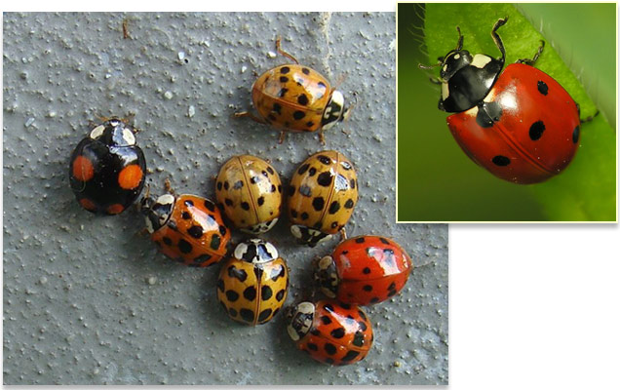
Credit: (left) Pbech/Wikimedia Commons; (inset) Dominik Stodulski/Wikimedia Commons
The innocuous-looking harlequin ladybird (Harmonia axyridis, shown left) wields a biological weapon of mass destruction. Europe and North America imported the insects in the early 20th century to control pesky aphids. But the harlequin, native to Asia, began to flourish, crowding out the native seven-spotted ladybug (Coccinella septempunctata, shown inset). Scientists previously thought that the harlequin prospered because of an unusually strong antimicrobial immune system, which would protect it from disease in a foreign environment. But the beetle's more potent secret is a fungal parasite, in the insect-afflicting Nosema genus, which lives in the beetle's blood. The parasite doesn't affect the harlequin but fatally overwhelms seven-spotted lady beetles within 2 weeks of infection, researchers report online today in Science. Ladybugs commonly eat the eggs of competing species, so when seven-spotted beetles feast on the harlequin's parasite-laden eggs, the parasite strikes back. Researchers say that foreign invaders fare better when they bring along diseases that they're already tolerant of, while other, closely related species (such as the seven-spotted ladybug) might not enjoy such conquistador-like success.


Asian lady beetles use biological weapons against their European relatives
May 17, 2013 No. 4/2013 (109)
Invasive species from Eastern Asia uses microsporidia in order to out-compete native lady beetles
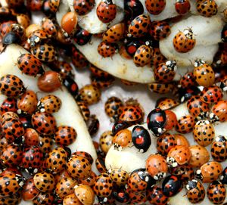
During spring and fall, mass occurrences of the Asian lady beetle can often be observed. Copyright: Andreas Vilcinskas, Justus Liebig University Giessen
Once introduced for biological pest control, Asian lady beetle Harmonia axyridis populations have been increasing uncontrollably in the US and Europe since the turn of the millennium. The species has been proliferating rapidly in Germany; conservationists fear that the Asian lady beetle will out-compete native beetle species. Scientists from the University of Giessen and the Max Planck Institute for Chemical Ecology in Jena, Germany, have now found the reason why this animal is so successful. Apart from a strongly antibiotic substance − a compound called harmonine − and antimicrobial peptides, its body fluid, the hemolymph, contains microsporidia. These tiny fungus-like protozoa parasitize body cells and can cause immense harm to their host. The Asian lady beetle is obviously resistant to these parasites in its own body. However, transferred to native species, microsporidia can be lethal.
The Asian lady beetle − a model organism for studying biological invasions
Because of its delicate, yet extremely variable, patterning, the lady beetle species Harmonia axyridis is sometimes called Harlequin ladybird. However, this insect has no comical characteristics. At the end of the last century, the species − which is native e.g. in China and Japan and therefore called Asian lady beetle − was successfully used in European greenhouses to keep aphid populations in check: It can devour hundreds of aphids per day, as well as many bug species or insect eggs. Yet today, this “bio killer” has escaped from the greenhouses and is spreading massively, but: A rapid and successful propagation of a neozoon − the biological term for a species which is invading new habitats and ecosystems − is not just an inevitable matter of course. In most cases, such a neozoon species doesn’t survive or else its population density remains very low, because original and adapted life forms usually prevail in their ecological niche and win interspecific competitions.
However, as soon as Harmonia axyridis is released into nature, it invades all habitats, especially those occupied by beetle species that feed on aphids. Within a very short period of time, native beetles are out-competed and the intruders have taken over. During the fall, major congregations of Asian lady beetles can be observed as swarms of insects search for hibernation places in houses or other sheltered areas. They are not only a nuisance, they can also cause serious allergic reactions in humans.
When prey becomes scarce, Asian lady beetles may feed on grapes as a substitute diet and hence, they are often found on grape-vines in vineyards in the fall. Once in the mash, the defensive chemical substances in their hemolymph negatively affect the taste of wine.
Like most ladybug species, the Asian lady beetle reflexively secretes fluid from its hemolymph as soon as it is attacked by potential enemies. Hemolymph fluid contains toxins and is therefore defensive. Can the Asian lady beetle’s secret of success be found in the hemolymph?
Microsporidia, tiny parasites present in the hemolymph of Harmonia axyridis, are the key to successfully out-competing native species
In comparison to other ladybug species, the hemolymph of H. axyridis contains a wide range of different antibacterial peptides − small proteins that insects use to fend off pathogens. Andreas Vilcinskas, Justus Liebig University in Giessen, Germany, and Heiko Vogel, Max Planck Institute for Chemical Ecology in Jena, Germany, studied the complex immune system of the insects and were able to isolate the genes that encode the enormous antimicrobial repertoire of H. axyridis. The hemolymph also contains a special substance, harmonine, which has a strongly antibacterial effect. Harmonine is only found in the hemolymph of H. axyridis, where is it abundant. Both the proteins and harmonine are of interest in medical research where they offer promising targets for the development of novel antibiotics, potentially even those against malaria.
When H. axyridis and its relative Coccinella septempunctata, which is native to Germany, are infected with pathogenic bacteria, both beetle species produce antibacterial peptides. However, the Asian lady beetle switches from a general hygiene using harmonine to an effective defense strategy based on dozens of peptides. “This alone, however, does not answer our main question: Is such a strong immune system, capable of fending off pathogens, the sole reason why H. axyridis is conquering the habitats of other beetle species all over the world? Can Harmonia out-compete other species just because it is more resistant to pathogens and, as a consequence, has a better chance to survive − or do other important factors play a role?” asks Heiko Vogel.
Although lady beetles generally compete for their common food source, aphids, some beetles also eat each other. This phenomenon, called intraguild predation, is an important factor in the competition among predating lady beetles − especially if they compete against the particularly aggressive invader H. axyridis. H. axyridis can feed on native lady beetles without harmful consequences. In contrast, native lady beetles that feed on H. axyridis die. How can that be?
A key experiment provided the answer to this question. The hemolymph of H. axyridis contains, apart from harmonine and antimicrobial peptides, a third defensive component: tiny biological weapons called microsporidia. These spores enable the invader to infect other beetle species, mainly because it is common among lady beetles to predate the eggs and larvae of other species. In their experiment, the scientists first injected harmonine into native C. septempunctata lady beetles, to establish whether this chemical substance harms the insects. In fact, the injection of hemolymph or purified microsporidia from H. axyridis had lethal consequences. A look through a high-resolution microscope revealed innumerable tiny spores in the hemolymph of the Asian lady beetle, spores that were even tinier than hemocytes. Microsporidic spores “germinate” and attack the cells of C. septempunctata; however, they do not germinate in H. axyridis. The Asian lady beetle can disable these biological weapons in its own hemolymph, but the spores become active as soon as they reach the body fluid of other beetle species. H. axyridis’ very strong immunity against pathogens and the effect of the microsporidia may explain the ecological success of the Asian invader as it continues to out-compete native species across Europe. Now the researchers are interested in finding out how H. axyridis can disable the microsporidia in its own hemolymph. [JWK/AO]
From: http://www.ice.mpg.de/ext/1025.html




Invasive Lady Beetle Kills Off Competition Using Parasites
Posted by Mollie Bloudoff-Indelicato on May 23, 2013
A ladybug pileup. Photograph by Ed Young, Corbis
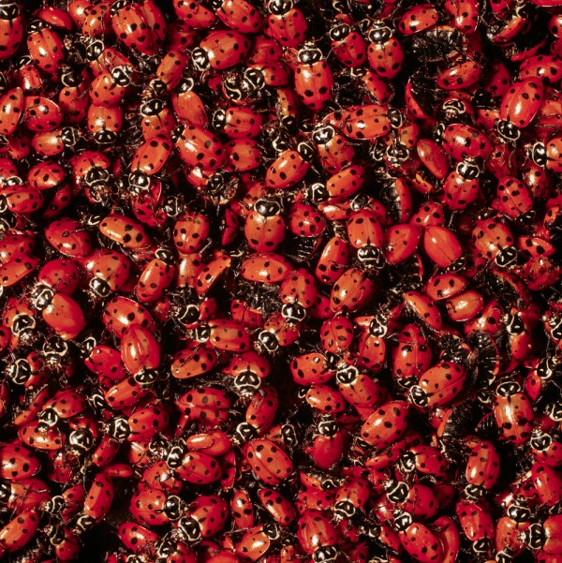
The Asian lady beetle (Harmonia axyridis)—a relative of the ladybug—was originally imported to the U.S. in 1916 in an attempt to naturally control pests. After escaping greenhouses, they spread uncontrollably throughout the U.S. and Europe in a matter of decades. But no one understood why they were such successful conquerors.
Now, a recent study published in Science finds that Asian lady beetles contain tiny fungus-like parasites that infect and kill native species, wiping out the invaders’ competition for food.
Asian lady beetles are aggressive, known to attack the larvae and eggs of other insects like butterflies and native lady beetles with which they compete. But that’s not what makes them so deadly. The invaders themselves contain high concentrations of a fungal parasite called microsporidia.
“If one of the native lady beetles eats larvae and eggs of Asian lady beetles, [the natives] die off,” said Heiko Vogel, a biologist at the Max Planck Institute for Chemical Ecology and co-author of the study.
“We were wondering, ‘What was going on there?’” he added.
Alien Invader
Vogel and his team identified Asian lady beetles from 12 different countries using physical examinations under a microscope and DNA analysis. After confirming the species, the researchers analyzed the beetles’ blood in order to figure out what was infecting and killing native bugs.
That’s when they found the fungal parasite lying dormant within the invaders. While Asian lady beetles are immune to the parasites, other insects are highly susceptible to its deadly effects.
“We didn’t believe our results at first,” Vogel said. “We wouldn’t have dreamed that this parasite, this fungus, would be a problem for the native beetles.”
When another insect eats an Asian lady beetle, the parasites activate. Microsporidia penetrate the new host’s cells, siphoning off its energy in order to multiply. The parasites continue to replicate until they’ve completely taken over and killed their host.
Then the fungus produces spores, which can survive harsh environmental conditions while waiting for the cycle to begin again. Asian lady beetles naturally contain a high concentration of these spores.
“We found these huge amount of spores in the blood of the Asian ladybird beetles, and we’re like, ‘What the hell?’” Vogel said. “When you see something like this, usually the insect is dead.”
The invaders are incredibly hardy insects. Asian lady beetles have a hyperactive immune system, which could be what’s protecting them from succumbing to the spores in their blood.
Unstoppable
And these conquerors aren’t just a problem for other insects. Every winter, Asian lady beetles gather by the thousands to weather the cold temperatures inside any cave-like dwelling they can find—including houses. Vogel’s own mother walked outside four years ago to find thousands of the pests attached to the side of her house, attempting to force their way in.
“They’re trying to sneak into crevices,” Vogel said. “You can’t open a window anymore or you’ll have thousands inside.”
The Asian lady beetles en mass have been known to cause health issues for people prone to asthma. They also give off a horrible smell when they sense danger as a deterrent against predators. One smelly beetle is nothing more than an annoyance, but if you have thousands of them, the stench can be a big problem, Vogel said.
Any efforts to eradicate the beetle, which also feasts on agricultural crops like grapes and apples, are likely a waste of resources, the biologist added. The bugs are just too resilient to control.
“I don’t think we can do a lot against [the Asian lady beetles],” Vogel said. “They’re so successful, and they’re spreading so fast. There’s no stopping them.”
From: http://newswatch.nationalgeographic.com/2013/05/23/invasive-lady-beetle-kills-off-competition-using-parasites/

ASSOCIATED TWEET: @NatGeo ---- Invasive Asian lady beetles contain tiny parasites that kill native ladybugs: http://on.natgeo.com/ZoTnKv (84 retweets)


Invasive ladybirds wage 'biological war' on natives
By Matt McGrath
16 May 2013
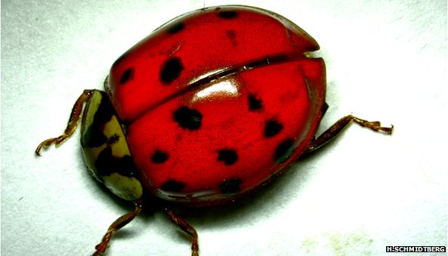
The Asian Ladybird or harlequin has overpowered native species across Europe.

German researchers have discovered the biological keys to the success of an invasive species, wreaking havoc across Europe and the US.

The Asian ladybird was originally brought in to control aphids in greenhouses.
But it has escaped and is increasing uncontrollably across Europe, wiping out native species.
The alien is winning, say scientists, because its body fluid contains a parasite toxic to other insects.
The research is published in the Journal, Science.

Sometimes called the harlequin, the Asian ladybird (Harmonia axyridis) can devour over two hundred aphids a day.
They are seen as a natural and effective solution to the problems posed by these pests in greenhouses.
Killer bugs
But in recent years these imported ladybirds have escaped and rapidly established themselves across Europe and North America at the expense of native species.
In Autumn, the Asian invaders can be a nuisance as they congregate in large groups searching for sheltered locations to hibernate.
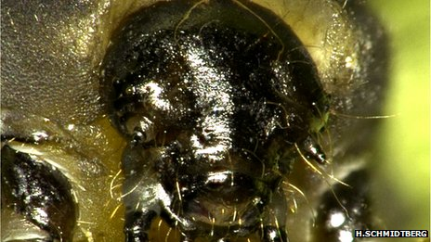
They can sometimes cause serious allergic reactions in humans.
[Photo: The larvae of the Asian ladybird can poison any native who eats it ]
In this new research, scientists have shown that it is the biological system of the Asian ladybird that gives it the edge when it comes to competing with native species.
The invader has an extremely powerful immune system.
The body fluid of the insect contains a strong antibiotic compound called harmonine as well as antimicrobial peptides. These allow the invasive to fight off pathogens more effectively than natives.
So powerful are the antibiotic elements in the ladybird, that the researchers say they may prove to be promising targets for drug development.
But the most powerful aspects of the ladybird's biological armoury are tiny fungi called microsporidia.
"They keep them inactive in their own blood, we don't understand how they do it yet," said Dr Heiko Vogel from the Max Planck Institute for Chemical Ecology,
"But when the other ladybird beetles start to attack the invader's eggs and larvae, they become active and kill the native ones."
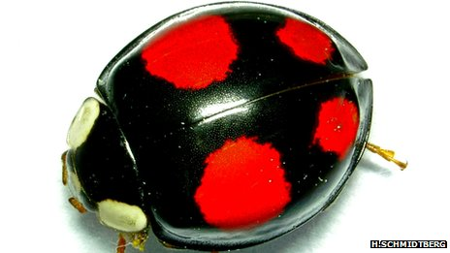
[Photo: The ladybird's immune systems have strong antimicrobial properties]
Several studies in recent years have shown the harlequin conquering other ladybirds across Europe. In the UK scientists found that seven of the eight native British species have declined. Similar problems have been encountered in Belgium and Switzerland.
In the UK, researchers are very keen for people to report any sightings of the harlequin. They have just launched a smartphone app that helps people record details of the ladybirds.
Dr Helen Roy from the Centre for Ecology & Hydrology near Wallingford, UK, said the German research was "fascinating". The outlook for native species, however, remained grim.
"The two-spot ladybird, a historically common and widespread species in Britain is suffering the most and experiencing dramatic and rapid declines," she said.
And the German scientists agree that the Asian ladybird is set to conquer most of the world.
"I don't see any which way to stop them now - it's too late in my opinion," said Dr Vogel.
"The fascinating thing is they can survive in such a wide range of temperature zones, and they are starting to pop up in South Africa and South America."
When the aphids they prey upon become scarce, Asian ladybirds are known to feed on grapes and are often found in vineyards. Their powerful, defensive chemicals can affect the taste of wine if they get trapped in the production process.
"They go on apples and grapes and that is becoming an increasing problem because of the massive amounts of these beetles, said Dr Vogel.
"The tainting of the wine with a single beetle is not funny!"
From: http://www.bbc.co.uk/news/science-environment-22554162


By Alex Reshanov on May 20, 2013

Invasive ladybugs: Secrets of their success
The harlequin ladybug gets a leg up on the natives with the aid of a parasitic fungus.
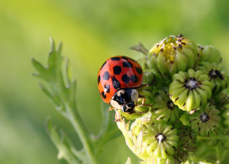
Image Credit: Strt's Photos
Not everyone has what it takes to be a successful invader. Most species that find their way to foreign lands starve, get eaten or otherwise fail to establish themselves in significant numbers. But every so often an organism thrives so well in its new terrain, that it ends up trampling much of the native flora and fauna. Harmonia axyridis – the harlequin ladybug – is one such formidable conqueror. Native to Asia, the ladybug (or ladybird if you prefer*) was deliberately introduced into Europe and North America during the 20th Century as a form of chemical-free pest control. I’m sure it seemed like a great idea at the time; Harmonia axyridis are voracious consumers of plant-plaguing aphids, and they’re darn cute by insect standards. What could possibly go wrong? Alas, as with many such introductions, the Asian ladybugs proved to be too much of a good thing, outcompeting equally adorable native ladybugs and then setting their sites on our fruit, including (gasp!) our wine grapes. Clearly, they’re a menace. But an impressive menace nonetheless. What’s their secret? Do they eat faster? Breed faster? Con the native ladybugs out of their lunch money?
One thing the harlequin ladybug has going for it is its ability to defend against a wide range of pathogenic microorganisms. This is useful when encountering unfamiliar microbes outside one’s native range (when in Rome, it’s best not to be too susceptible to Rome’s germs). But a recent study in Science suggests that the invasive harlequins may also be aided by another species, a single-celled parasitic fungus that functions as a biological weapon against native ladybugs.
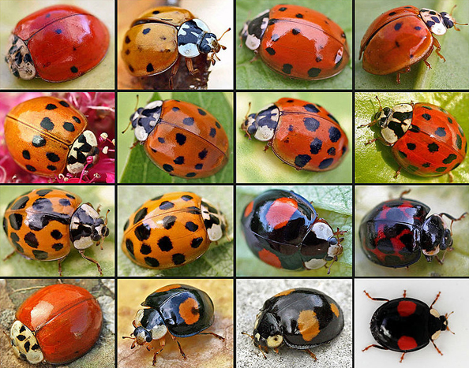
The many faces of the harlequin ladybug. Image: Entomart.

Something you should know about ladybugs in general – they often eat the eggs and larvae of competing ladybug species. For the harlequin ladybugs dining on native species’ young, this serves as both a nourishing snack and a means of reducing future competitors. But for native species partaking in little harlequins, the meal can be fatal. It was previously thought that the invasive ladybugs infused their eggs with a toxin to protect against this kind of predation. The metabolite harmonine (unique to the harlequins, and a contributor to their microbial resistance) was the likely cause of such interspecies poisonings. But when the authors injected native species Coccinella septempunctata (aka the seven-spot ladybug) with synthetic harmonine nothing happened. So much for that idea.
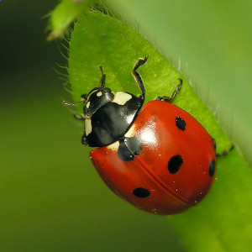
The seven-spot ladybug, with its reliable seven spot pattern. Image: Dominik Stodulski.
While scrutinizing the harlequin hemolymph (bug blood) for other possible culprits, the researchers found that it was teeming with a parasitic fungus of the Nosema genus. Hearty harlequins seemed unfazed by this fungus. It lounged around their blood in inactive spore form. But the less well-protected seven-spot ladybugs were easily taken down by the microbe, at least in the laboratory. Those injected with fungus isolated from the harlequin blood died within two weeks, while ladybugs dosed with a cell-free version of the hemolymph (i.e., no fungus present) survived the ordeal unscathed.
If these latest findings accurately reflect what goes on in the wild, this could mean that the harlequin ladybug owes its dominance to the combination of harboring and yet being resistant to an otherwise deadly parasite. Haven’t we seen this before somewhere? One obvious analogy is that of human invaders wiping out the locals by bringing along their homegrown germs. But for me the ladybugs brought to mind smaller organisms – bacteria. Soil dwelling bacteria are the original manufacturers of antibiotic drugs, and they developed these chemical weapons to eliminate nearby competitors and thus secure their food supply. In order to deploy such weapons, the bacteria had to protect themselves against these same chemicals, and so we also got antibiotic resistance genes as part of the package (less ideal for our species, but it’s working out quite well for the bacteria). Of course harlequin ladybugs aren’t making their own fungus, but there is some evidence that the spores are transmitted from parent to egg, and the whole arrangement seems strangely symbiotic. (Disclaimer: this is purely my speculation, not anything actually proposed in the article.)
And, as with bacteria-borne antibiotics, there may be something useful for us in this too. While the authors note that harmonine may not be the specific agent keeping the harlequin’s fungal residents in check, the compound has been shown to inhibit a variety of microbes, including those responsible for human ailments like tuberculosis and malaria. But if you’re trying to get rid of aphids, you might want to stick with soapy water.
* Entomologists would prefer that you prefer “ladybird” as these insect aren’t proper “bugs”, but I’m not that picky.
From: http://earthsky.org/earth/invasive-ladybugs-secrets-of-their-success



60-second science: PODCAST
May 17, 2013

Invasive Ladybug Thanks Its Parasite for Competitive Advantage
Harlequin ladybirds carry a parasite that does not kill them--but does kill other ladybug species that attempt to eat the harlequin progeny. Sophie Bushwick reports

PODCAST CONTENT: Ladybugs love to snack on aphids and other pests. So people began importing an Asian species called the harlequin ladybird as natural pest control. But in their new environments, the harlequins wiped out native ladybugs. And they have their parasites to thank. That’s according to research in the journal Science. [Andreas Vilcinskas et al., Invasive Harlequin Ladybird Carries Biological Weapons Against Native Competitors]
A parasite called microsporidia lies dormant in the circulatory systems of harlequin ladybirds. But when scientists injected microsporidia into a common European ladybug species, the insects died within two weeks. When the ladybugs were injected with dead microsporidia or a control substance most survived.
Harlequin ladybirds’ immune systems, on the other hand, have learned to deal with microsporidia—which lets the insects use them as biological weapons. Because one way ladybugs compete is by consuming the eggs and larvae of rival species. When European ladybug species eat the harlequin ladybird eggs and larvae, they also consume the microsporidia. And die.
The discovery demonstrates an important role of immunity in evolutionary selection. And it shows that there are many ways to lose a food fight.
—Sophie Bushwick
From: http://www.scientificamerican.com/podcast/episode.cfm?id=invasive-ladybug-thanks-its-parasit-13-05-17

Babikova et al.
Underground signals carried through common mycelial networks warn neighboring plants of aphid attack

Ecology Letters
2013

ScienceShot: Fungi Provide an Early Warning System for Plants
by Susan Langthorp on 17 May 2013, 12:20 PM
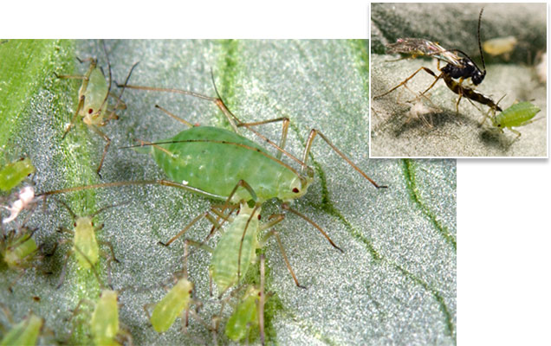
Credit: Rothamsted Research

The deal between plants and soil fungi is well known. The fungus takes soluble carbohydrates such as sugars from the plant's roots, while the plant makes use of extra soil minerals absorbed by the extensive surface area of the fungal mat or mycelium. Now, it appears that the plant gets something extra in the bargain. When a bean plant (Vicia faba) is infested with aphids, it produces a cocktail of chemicals that repels the insects but attracts a natural aphid predator, the wasp (inset). Even bean plants not attacked by aphids produce these chemical defenses—as long as they are connected to the besieged plants via a fungal mat—a team reports online this month in Ecology Letters. The researchers don't know exactly how the danger is communicated but the possibility of aboveground signaling was ruled out: The plants were covered with bags. The most likely mechanism, they say, is chemical communication by means of the fungal network. The roots of many important food crops including wheat, rice, and maize exist cheek by jowl with symbiotic fungi, and this has major implications for green pest control of the aphid (main picture). Strategically placed plants throughout the crop would trigger the chemical response for the benefit of the other plants. Altruistic? Yes, but a few plants sacrificed for the health of the whole field makes economic sense in the war against this agricultural enemy.



Plants use underground networks to communicate danger


Friday, May 10, 2013
Plants use underground fungal networks to warn their neighbours of aphid attack, scientists from the University of Aberdeen, the James Hutton Institute and Rothamsted Research have discovered. The study, published in Ecology Letters, is the first to reveal plants’ ability to communicate underground in this way.
The research changes our understanding of the ways in which living things interact with one another. If crops can be managed in a way that exploits this natural communication channel, it could provide a new weapon in the battle against insect pests.
Scientists grew the bean plant (Vicia faba) in groups of five. They allowed three in each group to grow underground networks of mycelia – a thread-like fungus that grows from one set of roots to another. They kept the two remaining plants free of the fungal links. They then infested one of the plants in each group with aphids, triggering the release of a suite of chemicals designed to repel aphids but attract wasps, one of the aphid’s predators.
Remarkably, plants which were not under attack themselves, but which were connected to the victim by the underground fungal network, also began to produce the defensive chemical response. Unconnected plants didn’t mount a chemical defence, so remained vulnerable to aphid attack. Previous research had shown that plants could communicate chemically through the air, but the researchers covered the plants with bags to rule out above-ground signalling.
Dr David Johnson, of the University of Aberdeen, led the study. He said: “We knew that plants produce volatile chemicals when attacked, and we knew they communicate danger to each other above ground. Now we know that they communicate danger through these underground fungal networks as well. Connected plants that weren’t infested by the aphids behaved as though they were. We don’t quite know the mechanism, but it’s likely to be a chemical signal. Our understanding of ecological systems has not considered the fact that plants are interconnected in this way. It could have major implications for our understanding of how one organism affects another.”
Dr Lucy Gilbert, senior ecologist at the James Hutton Institute and co-author of the study, commented: “It is fascinating that different individual plants can be connected to one another by underground fungal networks and it is even more amazing that plants may use these connections as early warning systems of aphid attack. Our research indicates that these connections, by being a conduit for signals between plants, affect the plants, the aphids and the parasitoids that are enemies of the aphids. This may have implications for crop pest control. The next research challenge is to identify the signalling compound being transported through the fungal network.”
Another of the study’s authors, Professor John Pickett of Rothamsted Research, said: “Aphids affect all higher-latitude agricultural regions, including the UK, the EU, North America, and North East Asia. This research could provide a new, sustainable and natural intervention. In a field of plants that have some inducible resistance to aphids, we could use a plant that’s susceptible to aphid attack to ‘switch on’ the defence mechanism through the natural underground connection. There’s the potential to deal with other pests and diseases, in other regions, in a similar way.”
From: http://www.hutton.ac.uk/news/plants-use-underground-networks-communicate-danger


10 May 2013

Fungus network 'plays role in plant communication'
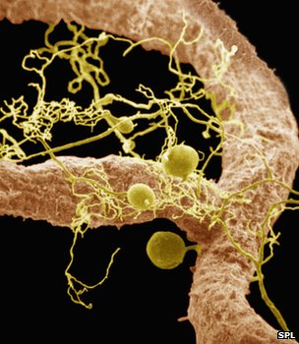
Mycorrhizae are mutualistic - they both need and are needed by the plants whose roots they inhabit

Plants can communicate the onset of an attack from aphids by making use of an underground network of fungi, researchers have found.
Instances of plant communication through the air have been documented, in which chemicals emitted by a damaged plant can be picked up by a neighbour.
But below ground, most land plants are connected by fungi called mycorrhizae.
The new study, published in Ecology Letters, demonstrates clearly that these fungi also aid in communication.
It joins an established body of literature, recently reviewed in the Journal of Chemical Ecology and in Trends in Plant Science, which has suggested that the mycorrhizae can act as a kind of information network among plants.
Researchers from the University of Aberdeen, the James Hutton Institute and Rothamsted Research, all in the UK, devised a clever experiment to isolate the effects of these thread-like networks.
The team concerned themselves with aphids, tiny insects that feed on and damage plants.
Many plants have a chemical armoury that they deploy when aphids attack, with chemicals that both repel the aphids and attract parasitic wasps that are aphids' natural predators.
The team grew sets of five broad bean plants, allowing three in each group to develop mycorrhizal networks, and preventing the networks' growth in the other two.
To prevent any through-the-air chemical communication, the plants were covered with bags.
As the researchers allowed single plants in the sets to be infested with aphids, they found that if the infested plant was connected to another by the mycorrhizae, the un-infested plant began to mount its chemical defence.
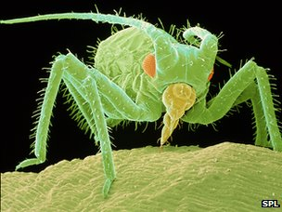
Some strains of wheat have been genetically modified specifically to resist the aphid threat

Those unconnected by the networks appeared not to receive the signal of attack, and showed no chemical response.
"Mycorrhizal fungi need to get [products of photosynthesis] from the plant, and they have to do something for the plant," explained John Pickett of Rothamsted Research.
"In the past, we thought of them making nutrients available from the [roots and soil], but now we see another evolutionary role for them in which they pay the plant back by transmitting the signal efficiently," he told BBC News.
Prof Pickett expressed his "abject surprise that it was just so powerful - just such a fantastic signalling system".
The finding could be put to use in many crops that suffer aphid damage, by arranging for a particular, "sacrificial" plant to be more susceptible to aphid infestation, so that when aphids threaten, the network can provide advance notice for the rest of the crop.
"Now we've got a chance in a really robust manner of switching on the defence when it is needed - not straining the plant to do it all the time - and to reduce the development of resistance (of the aphids to the plants' defences)," Prof Pickett said.
From: http://www.bbc.co.uk/news/science-environment-22462855



Evidence plants communicate via underground fungal networks
By Rog Wood, Farming correspondent | Friday 10 May 2013
PLANTS use underground fungal networks to warn their neighbours of aphid attack, according to researchers.
The study, published this week in Ecology Letters, is the first to reveal plants' ability to communicate underground in this way.
The research changes our understanding of the ways in which living things interact with one another. If crops can be managed in a way that exploits this natural communication channel, it could provide a new weapon in the battle against insect pests.
Scientists from Aberdeen University, the James Hutton Institute and Rothamsted Research grew the bean plant in groups of five. They allowed three in each group to grow underground networks of mycelia – a thread-like fungus that grows from one set of roots to another. They kept the two remaining plants free of the fungal links.
They then infested one plant in each group with aphids, triggering the release of chemicals to repel aphids but attract wasps, one of the aphid's predators.
Remarkably, plants which were not under attack themselves, but were connected to the victim by the underground fungal network, also began to produce the defensive chemical response. Unconnected plants did not mount a chemical defence. Researchers covered the plants with bags to rule out above-ground signalling.
Dr David Johnson, of Aberdeen University, who led the study, said: "We knew that plants produce volatile chemicals when attacked, and we knew they communicate danger to each other above ground. Now we know they communicate danger through these underground fungal networks as well.
"We don't quite know the mechanism, but it's likely to be a chemical signal. Our understanding of ecological systems has not considered the fact that plants are interconnected in this way. It could have major implications for our understanding of how one organism affects another."
The roots of virtually all groups of plants, including important food crops such as wheat, rice, maize and barley, are colonised by symbiotic fungi.
From: http://www.heraldscotland.com/business/farming/evidence-plants-communicate-via-underground-fungal-networks.21041866



Plants use underground fungus network to send ‘distress signals’ to each other
By David Ferguson
Friday, May 10, 2013 15:04 EDT

[image via Shutterstock.com]
British researchers released a study on Thursday saying that plants can communicate with each other by using an underground network of fungi. According to the BBC, the study, published in the journal Ecology Letters, said that plants signal each other when they are under attack by aphids to that other plants can secrete chemicals that repel aphids and attract the wasps that are the aphids’ natural predators.
Scientists from the University of Aberdeen in Scotland, the James Hutton Institute and Rothamstead Research joined forces to devise an experiment to test what role these threadlike fungi, called mycorrhizae, play in aiding communication between plants in distress.
The type of distress they chose to inflict on the plants and test their response was an attack by aphids. Aphids are tiny insects that feed on a variety of plants and many plants have developed an arsenal of chemical defenses to use against them.
The research team grew sets of five broad bean plants. In each set of five, three were allowed to grow mycorrhizal tissue around their roots. Two were prevented from doing so.
The scientists then isolated the plants from each other above ground, covering them with bags and thereby preventing airborne chemicals (one form of plant communication) from traveling from one plant to the other. Then, the team introduced the aphids.
In the plants that were connected by fungi, when a single plant was infected with aphids, the other two plants began to mount their chemical defenses, secreting aphid-repelling substances that also attract the wasps that feed on aphid larvae. The plants that were not connected by mycorrhizae were apparently not warned of the attack on the single plant in their group because they secreted no defensive chemicals.
When the bean plants come under attack, their chemical defenses trigger a reaction in the chemical composition of the fungi, causing a chain reaction that leads to the next bean plant, which, in its turn, detects the distress chemicals in the fungi and reacts by releasing its own chemical defenses.
John Pickett of Rothamsted Research told the BBC that the fungi are engaged in a two-way relationship with the bean plants.
“Mycorrhizal fungi need to get [products of photosynthesis] from the plant, and they have to do something for the plant,” he said. “In the past, we thought of them making nutrients available from the [roots and soil], but now we see another evolutionary role for them in which they pay the plant back by transmitting the signal efficiently.”
The discovery took scientists by surprise, but Pickett calls the fungal network “a fantastic signaling system.”
The team hopes that their discovery can contribute to pest-resistance and additional hardiness for food plants in the field.
From: http://www.rawstory.com/rs/2013/05/10/plants-use-underground-fungus-network-send-distress-signals-to-each-other/



Fungal network helps plants communicate

It’s like playing telephone, but more science-y.
Researchers have found plants use an underground network of fungi to warn each other of attacks by aphids, small insects that feed on and can destroy plants, according to phys.org. The research was published in Ecology Letters and was conducted by researchers at the University of Aberdeen and Rothamsted Research.
Below ground, most plants are connected by thread-like fungi called mycorrhizae. Researchers grew bean plants in groups of five then let three in each group grow mycorrihizal mycelia. The remaining two plants in each group were kept fungi-free, according to the University of Aberdeen.
Researchers then released aphids on one plant in each group. The plants responded by releasing chemicals to call in the troops – that is, to repel aphids and attract wasps that feed on the tiny bugs. Researchers found plants that weren’t infested but connected to the aphid-besieged plant by fungi also began producing these chemicals. Conversely, plants that weren’t connected via the network didn’t produce the aphid-repelling chemicals.
This is the first time a study has shown the link between the underground fungal network and plant communication. Previous studies have demonstrated how plants can communicate through the air.
Besides the obvious cool factor, this research has an extremely valuable upshot – if this underground fungal communication network can be leveraged with crops, for example, it would provide an innovative new tool in warding off destructive pests, the statement notes.
“Aphids affect all higher-latitude agricultural regions, including the (United Kingdom), the (European Union), North America, and North East Asia. This research could provide a new, sustainable and natural intervention,” said Prof. John Pickett of Rothamsted Research, in a statement. “In a field of plants that have some inducible resistance to aphids, we could use a plant that’s susceptible to aphid attack to ‘switch on’ the defense mechanism through the natural underground connection. There’s the potential to deal with other pests and diseases, in other regions, in a similar way.”
From: http://www.neogen.com/blog/fungal-network-helps-plants-communicate/#sthash.t8shYCEE.dpbs

Pincebourde, Sanford, & Helmuth
Survival and arm abscission are linked to regional heterothermy in an intertidal sea star

Journal of Experimental Biology
2013

ScienceShot: How Starfish Sweat
by Paul Gabrielsen on 29 May 2013, 6:00 PM
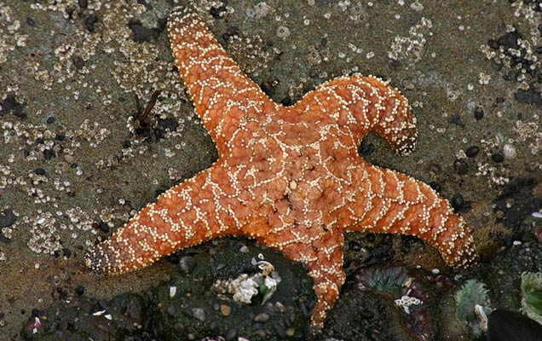
Credit: Wing-Chi Poon

Dogs pant. Humans sweat. But how do starfish keep from overheating? At the hub of a sea creature's five arms (or more, in some species) is the central disk, which holds the animal's heart, stomach, and central nervous system. If this disk's temperature rises above 35°C (such as at low tide, when the animal may be isolated from cool ocean water) the starfish dies. To figure out how the animal stays cool, scientists collected 70 ochre starfish (Pisaster ochraceus) from the California coast and placed them under heat lamps to simulate potentially lethal low tide heat exposure, at temperatures ranging from 26°C to 42° C. About one-third of the starfish died when their central disk temperatures reached 35°C, the team reports online today in The Journal of Experimental Biology. Researchers found that the arms of surviving starfish were a few degrees warmer than the disk, as warm as 39°, suggesting that the animals shunted heat into their extremities. The strategy is not without a cost, however. In the days following the experiment, 16 of the surviving starfish severed their own heat-damaged arms, which are costly to regrow.

 [this story was published in the same issue of the journal as the original science article]

A SEA STAR'S CHOICE: HOT ARMS OR DEATH
By Nicola Stead
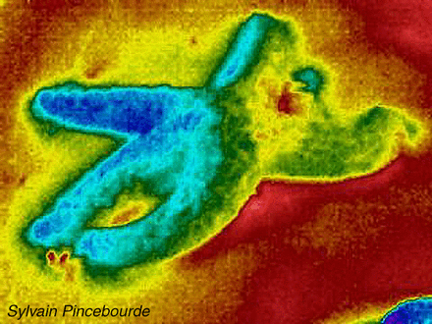
Life isn't easy for a sea star living in the intertidal zone. Daily tides leave them exposed and without access to cooling seawater for up to 6 h. As ectothermic animals, sea stars are unable to control their own body temperatures and if not careful they can find themselves precariously heating up during their daily aerial stints. But how hot is too hot? From the perspective of the sea star's central disc, which houses critical organs such as the stomach, 35°C is the upper limit before death – but what about the arms, do they have a different limit? Sylvain Pincebourde, currently a Centre National de la Recherche Scientifique researcher at the Institute of Research on Insect Biology, France, explains that until now most scientists have assumed that body temperature is even throughout the sea stars' bodies. However, with their characteristic spindly appendages, which should in theory allow a significant amount of heat to be lost via convection, their arms could be cooler. So, as part of his post doc at the University of South Carolina, USA, Pincebourde decided to investigate further. He wondered how sea star arms coped during low tide and whether arm temperature affected a sea star's decision to undergo arm abscission, a rare phenomena with an unknown trigger (p. 2183).
With the help of Eric Sanford and Pincebourde's post-doctoral mentor, Brian Helmuth, from the University of California Davis, USA, Pincebourde collected 70 sea stars off the coast of California. After acclimating them to the lab, the team grouped their aquatic testees into 10 groups, placing each group in an empty aquarium. Monitoring them with an infrared camera, the team found that, as expected, body temperature was indeed heterogeneous. However, in contrast to their initial expectations, the arms were warmer, not cooler, than the sea star's vital core. Perhaps convective heat loss played more of a role during their long periods out of water?
To mimic the hot conditions encountered during low tide, the team used overhead heat lamps to set and maintain the sea stars' core temperatures for 6 h. Each group was heated to a different core temperature, ranging from a bearable but warm 26°C to a deathly 42°C. Again, the team found that the sea stars' arms remained consistently higher than core body temperatures, ranging from 29 to 39°C when the core body temperatures were set to 26–35°C. As expected, these sea stars survived their warm spell, whereas sea stars with core temperatures set between 36 and 43°C weren't so fortunate and died within 24 h. Their deaths were expected due to their core temperatures being set so high, but the team were interested to find that these unlucky sea stars were also the only sea stars with arm temperatures lower than their core, ranging from 34 to 40°C.
The team think that the sea stars use their arms as heat sinks, actively drawing away heat from the essential core, to aid survival. While this may ensure a cooler core, it is not without its own disadvantages. When arms reached 33–39°C, after 2 days at least one arm would undergo abscission. Heating the arms to their own thermal limit is a sacrifice sea stars may make to ensure that core remains below 35°C. After all, it's better to lose an arm and save a life than die with five intact arms.
© 2013. Published by The Company of Biologists Ltd
From: http://jeb.biologists.org/content/216/12/i.1

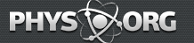

Study finds starfish shed arms to protect against overheating

May 31, 2013 by Bob Yirka
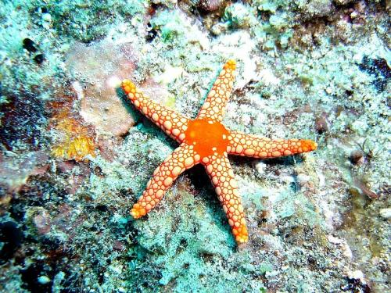
A Starfish in Mauritius. Credit: Alain Feulvarch/Wikipedia
A team of marine biologists has found that some starfish lose a leg when faced with too-warm environmental conditions. In their paper published in The Journal of Experimental Biology, the researchers describe what they witnessed as they subjected 70 starfish to various heated environments and filmed the results with infrared cameras.
Starfish are considered to be a cold-blooded animal—they can't adjust their internal temperature as environmental temperatures change. Because of this, they are at the mercy of weather conditions. This can be a problem for them when tidewater recedes leaving them stranded on a beach exposed to the hot sun. Until now, most biologists have believed that starfish, like most other cold blooded animals, have a uniform internal body temperature reflective of the temperature around them.
To find out how the starfish survived changes in heat, the research team captured 70 ochre starfish found living off the California shore and subjected them to heat related tests. Groups of the starfish were put into different tanks with different temperatures and were then filmed using an infrared camera to see what was going on with heat distribution inside of their bodies. To their surprise, they found that the temperature in the legs of the starfish was different than that of their core—the disk at the center of their legs that holds their vital organs. They also found that starfish have a definite limit on core temperature—if it reaches 35 C they die. Most remarkably of all they discovered that if the starfish were subjected to high temperatures for very long, they would engage in abscission (intentional shedding of a body part) of their legs.
More specifically, the team found that all of the starfish were able to keep their central disk 3 C to 5 C cooler than their arms, suggesting that the animals were using their legs as heat sinks. In extreme cases, the diversion of heat to arms would cause the arms to shrivel up and fall off—though that shouldn't be a problem for them as starfish are able to regenerate lost legs.
The findings by the team are the first time that arm loss in an animal has been seen to be attributable to thermal regulation. They also show that not all starfish leg loss is due to predators.
From: http://phys.org/news/2013-05-starfish-arms-overheating.html

Starfish sacrifice arms to beat the heat
23:00 29 May 2013 by Zoe Cormier
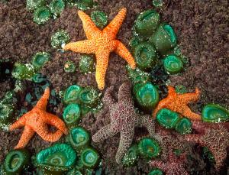Willing to use extreme measures to stay cool (Image: Brandon D. Cole/Corbis)
You can tell when a starfish is too hot – it loses an arm. The remarkable behaviour is part of a surprising strategy that may allow the animals to survive in warmer waters than previously thought possible.
Ecologists tend to think that cold-blooded animals, called ectotherms, are incapable of changing their body temperature and instead simply take on the temperature of their environment. Sylvain Pincebourde at the Institute of Research on Insect Biology in Tours, France, and Eric Sanford at the University of California, Davis, had a hunch that things are more complicated than that.
To investigate, they collected 70 ochre starfish (Pisaster ochraceus) from the coast of California. They housed them in 10 tanks, set to different temperatures ranging between 26˚C and 42˚C, and monitored the body heat of the starfish with infrared cameras.
Their work confirmed that body temperature varies across the starfish rather than being uniform. Each animal's central disc was always cooler than its five arms, by anywhere from 3˚C to 5˚C.
If the temperature of its central core rose above 35 ˚C, the starfish died – its vital organs unable to function in the heat, says Sanford. Its arms, however, could withstand those temperatures – although if they remained at around 35 ˚C for more than a few days, one or more of the arms typically turned soft and fell off.

Heat sinks
The team isn't sure how starfish regulate the temperature in the different parts of their bodies. One possibility is that the animals actively divert heat into their arms, which can then release the heat into the water relatively efficiently because of their large surface area and small internal volume.
This could explain why animals that are particularly warm for an extended period lose an arm or two: by using them as heat sinks, the starfish may thermally damage their arms beyond repair.
We know that starfish can lose arms to predators and later regrow them again, but this is the first time researchers have shown that arm loss can be related to thermal regulation.

Musselling in
Starfish are a key predator off the coast of California. "They influence what the populations of mussels and other animal communities look like," says Sanford. This means any change to the starfish population as a result of climate change could trigger a cascade of knock-on effects further down the food chain. So understanding how these animals respond to temperature change should help ecologists understand how regional changes in climate might affect coastal ecosystems, he says.
Mark Denny of Stanford University in California studies the mussels the starfish prey on. "The mussels for their part would love to not have the starfish around," he says. "The fact that the starfish are good at cutting losses and surviving [in warmer water] is bad news for the mussels."
Any evidence that some marine organisms have ways to deal with warmer water could be significant as global temperatures continue to rise. "[The work] might spur other researchers now to look at other keystone species in the same way, with physiologists and ecologists coming together to understand how temperature changes will affect populations and communities," says Denny.

From: http://www.newscientist.com/article/dn23615-starfish-sacrifice-arms-to-beat-the-heat.html



Les bras ou la vie : le dilemme des étoiles de mer

[translates to]

Arms or life: the dilemma of the starfish

15:13, 31 May 2013
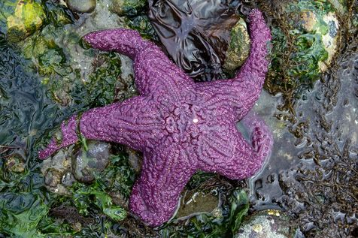
A purple starfish. (Photo Canopic. CC BY Flickr)

A team of California researchers looked at the process of thermal regulation of sea stars, which requires them to choose between taking the risk of losing one or more arms, or die of overheating.
By Virginia BALLET
On beaches soon overheated, a number of options are available to the human to regulate its body temperature: settle in the shade, swim, sip a drink, or simply sweat. Nature has apparently been less lenient with starfish (Asteroidea). They must choose between the risk of dying of hyperthermia, or ensuring their survival to apportion their body heat in their five arms.
This finding comes from the work of a team of researchers from the University of South Carolina (United States) published Wednesday in The journal of experimental biology. Under the direction of Sylvain Pincebourde, researchers Eric Sanford and Brian Helmut looked at thermal regulation of ochre sea stars (Pisaster ochraceus). At low tide, these echinoderms may find themselves out of the water for more than six hours, far from any source of cooling. These ectothermic organisms see their temperature change depending on the environment where they live.
How, therefore, to manage the heat? To get to the bottom of this, the scientists placed 70 purple sea stars from the Californian coast under lights to heat, reproducing their natural environment in the laboratory at temperatures between 26 and 42 ° C. All tanks were equipped with infrared cameras. Sea stars were divided into seven groups, all heated to different temperatures. Objective: to determine the temperature at which their life is in danger.
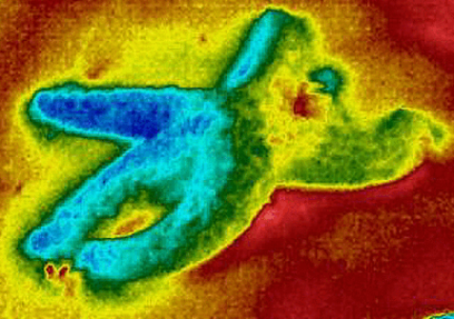
The star of sea view via an infrared camera. Photo by Sylvain Pincebourde
Sea stars have a sort of 'central hard drive', which contains the heart, stomach and nervous system. This hard drive is sensitive to heat. One-third of guinea pigs die when the temperature of this 'hard drive' exceeds 35 ° C.
Sea star survivors reveal a surprise: contrary to what the scientists expected, the sea stars’ body temperature was not homogeneous. Their arms were warmer than their hearts. In fact, some of their arms reached between 29 and 39 ° C, while the central 'hard drive' was between 26 and 35 ° C.
In this lies the sea stars’ secret to survival: they divide their body heat by dissipating it into their five arms. But all is not so rosy on the Californian coast: within two days of experimentation, sixteen surviving stars faced a process of abscission and have lost at least one of their arms. 'After all, better to lose an arm and save a life than die with five arms,’ say the authors of the study.
From: http://www.liberation.fr/sciences/2013/05/31/les-bras-ou-la-vie-le-dilemme-des-etoiles-de-mer_907184

